Assignment for EE5101 Linear Systems:

Modeling and Control of a Stationary Self-Balancing Two-wheeled Vehicle

Name: XU Shulue

Matriculation Number: A0259887Y

Email Address: e0973729@u.nus.edu

Date: 11/11/2022

**Abstraction:**

a stationary self-balancing two-wheeled vehicle is an application of the control system design. In this project, the author employs the principles of control system operation and design to analysis the system and observe the behaviour of the system under different control methods, including pole placement, LQR, decoupling control, servo control. Apart from that, observer is designed to reduce the possible number of sensors need to monitor the system.

Contents Table

1. **Introduction**

The report models the system and states the system parameters in section 2.

The main part of the report shows the design details of several possible control methods that can be used for a self-balancing vehicle application, including pole placement, LQR, servo control, and decoupling control to satisfy specific design requirements on transient response overshoot and setting time in section 3. More specifically, the overshoot is set to be less than 10% while the setting time is less than 5 seconds. For the servo controller design, a possible way of combining the servo controller and observer is proposed so that the control can be adapted to a scenario where only sensors for the system output can be used.

In section 3, apart from the design details, the report also includes the simulation results. The results are also presented as a window to see how different design parameters, such as places of poles, weighting factors, etc, can affect the system performance.

Finally, the report summarizes the general relationship between design parameters and the system behaviour in the conclusion in section 4.

1. **System Modelling and Overall Design Requirement**

The overall system of the vehicle can be seen as an LTI system, whose state space model takes the form:

(Eq. 1)

(Eq. 2)

Choosing the states, input, and output as stated in the specification gives the system parameters:

(Eq. 3)

(Eq. 4)

(Eq. 5)

(Eq. 6)

To meet the requirements of transient response, choose several sets of stable poles as in Table 1:

|  |  |  |  |  |  |  |
| --- | --- | --- | --- | --- | --- | --- |
| Poles Sets |  |  |  |  |  |  |
| Set 1 | -1.8-0.872j | -1.8+0.872j | -6 | -7 | -8 | -9 |
| Set 2 | -1.6-1.2j | -1.6+1.2j | 7.04 | -7.36 | -7.68 | -8.0 |
| Set 3 | -1.2-1.6j | -1.2+1.6j | -4.8 | -5.4 | -5.76 | -6.0 |

Table 1: The Set of Stable Poles

1. **System Controlling**
   1. **Control By All State Variables Using Pole Placement**

The aim of this section is to introduce a design of controller that can stabilize the system so that the output can converge to a non-specified final value, meanwhile satisfies the overall design requirement. Pole placement method is utilized to complete such a task in this section.

* + 1. **Controller Design**

The key of pole placement is to stabilize the system by placing the system poles to the negative-half of the s-plane. So one must specify the objective negative poles to be placed for a pole placement problem. Since the general requirements for overshoot and settling time have to be met, the chosen poles are as shown in Table 1.

Since the system is MIMO, full rank method is leveraged to accomplish the task. The controllability matrix is worked out by:

(Eq. 7)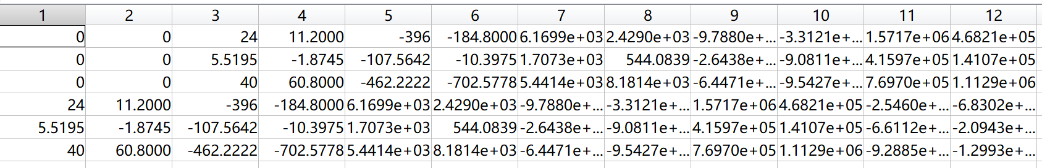

Figure 1: the Controllability Matrix

The first 6 columns of are linearly independent. Thus, choose the first 6 columns and rearranged them into as shown in Figure 2.

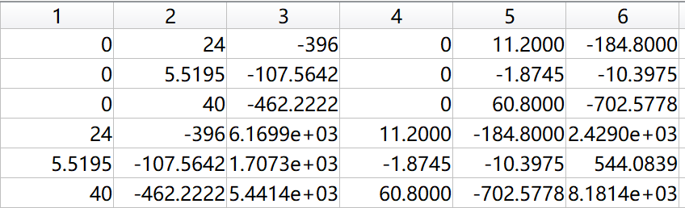

Figure 2: The Matrix

The first 3 columns of are related to the first input while the rest 3 columns are related to the second input. Thus, we have . In this case, to construct the transformation matrix , one need to choose the and rows of . Set the third and sixth rows of to be and , the transformation matrix is given by Equation. The values of is shown in Figure 3.

(Eq. 8)

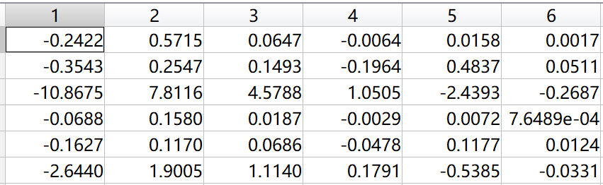

Figure 3: The Transformation Matrix

Transform the system matrices and to be and . For the new system with and , set the state feedback input to be to place the poles of the new system at the stable poles. Meanwhile, construct the objective controlled system matrix to be . The form of is designed as in Eq.9.

(Eq. 9)

Then can be worked out as shown in Figure 4.

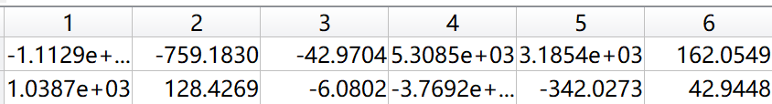

Figure 4: The Matrix

Finally, the state feedback gain of the original system is . The values in is shown in Figure 5.

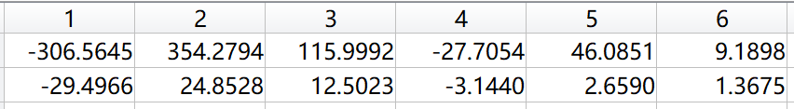

Figure 5: The Matrix

The overall closed-loop system can be designed with feedback gain , as displayed in Figure 6.

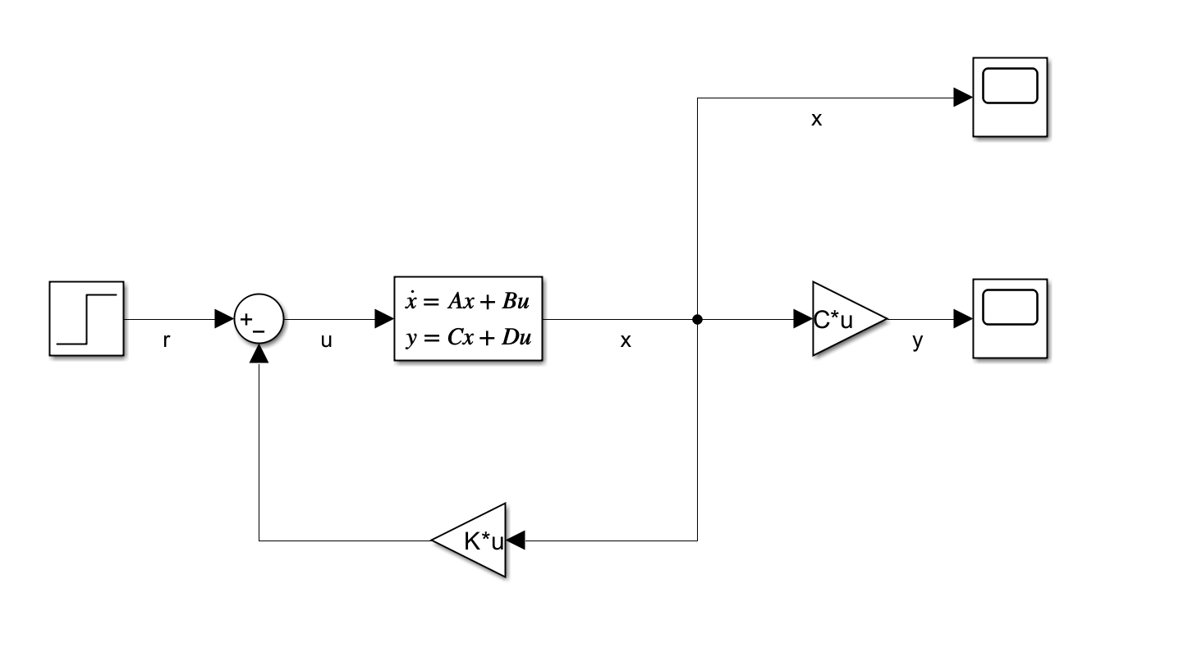

Figure 6: The Controlled System Design with Pole Placement

* + 1. **Simulation Results**

To check if the transient response of the closed-loop system meets the general requirements, let the reference input to be or . The simulation results for two cases are respectively shown in Fig and Fig.

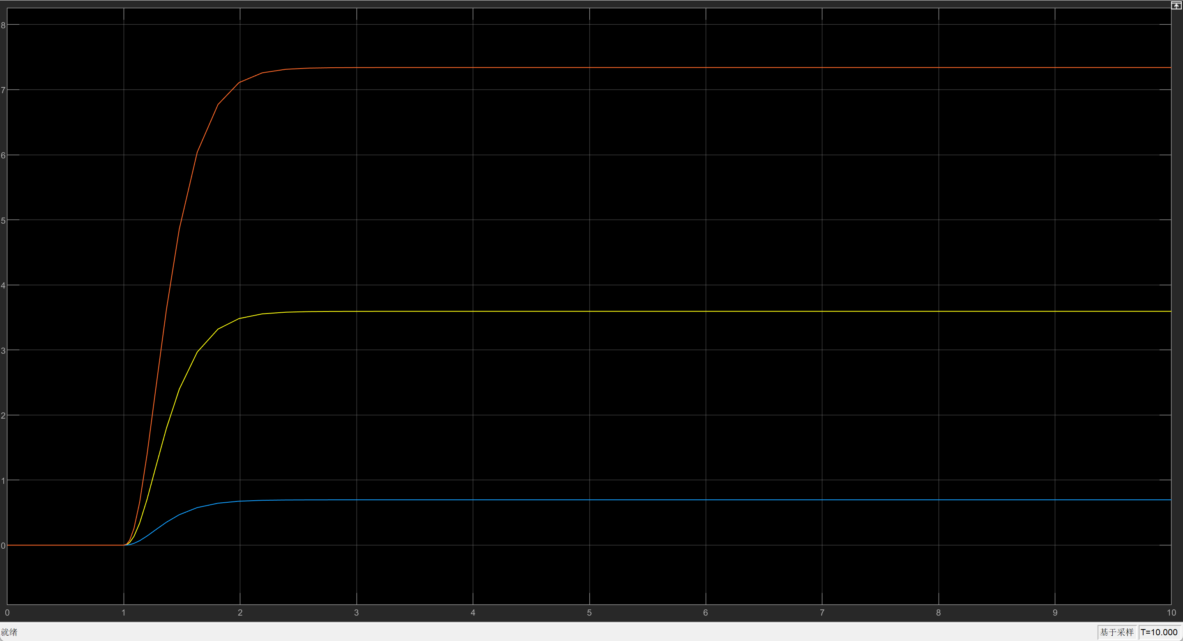

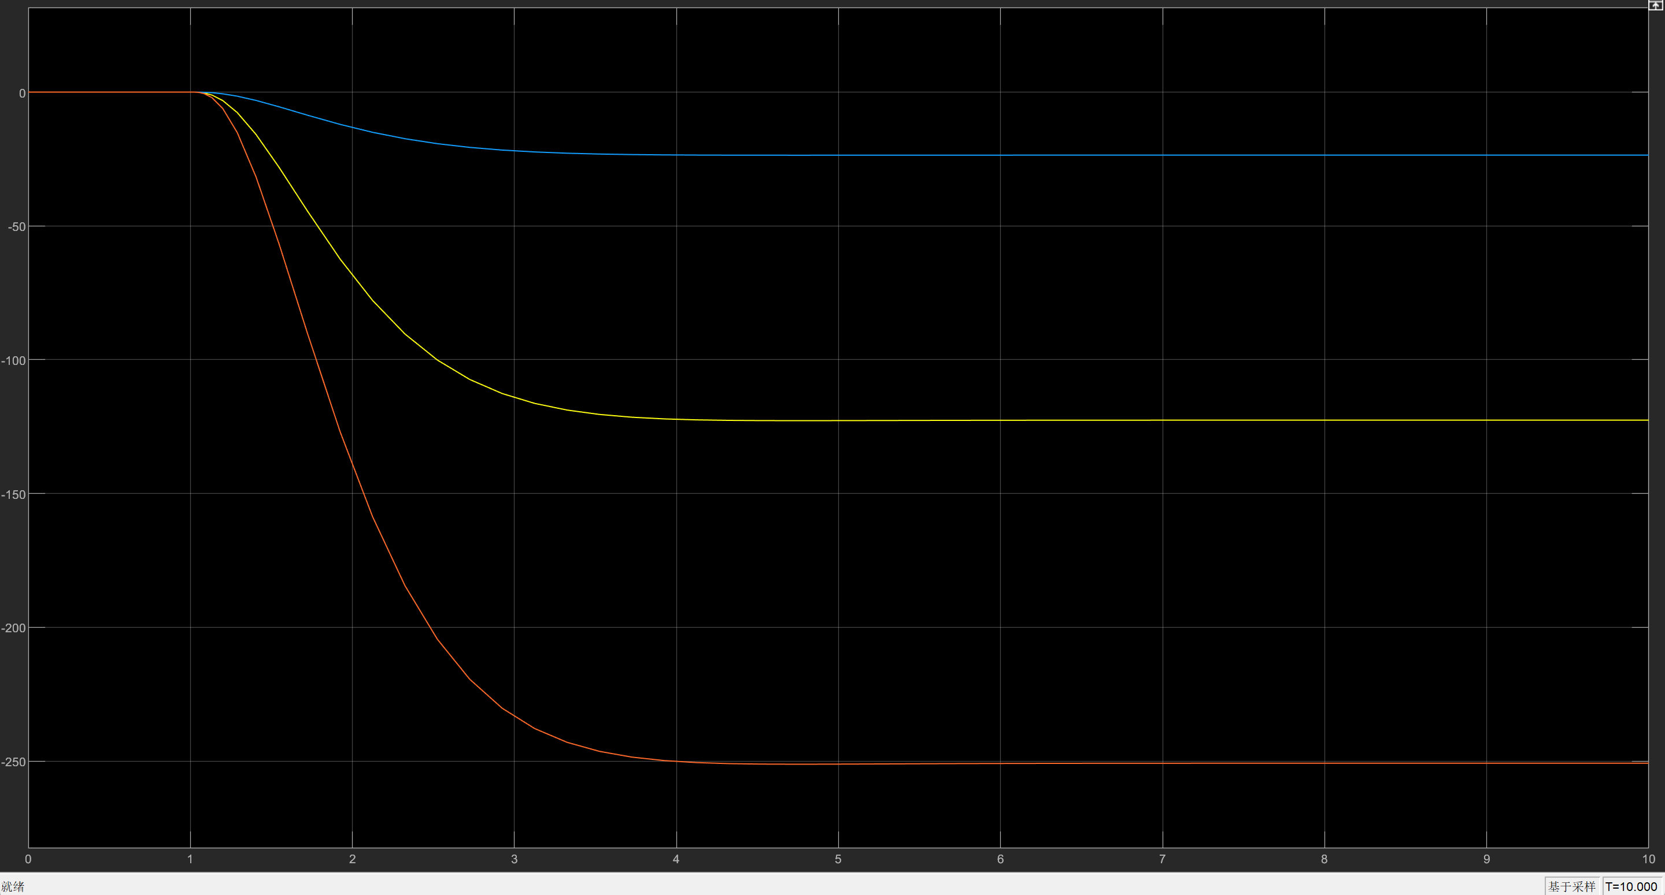

For the zero input response with initial state being , the simulation result is shown in Fig.

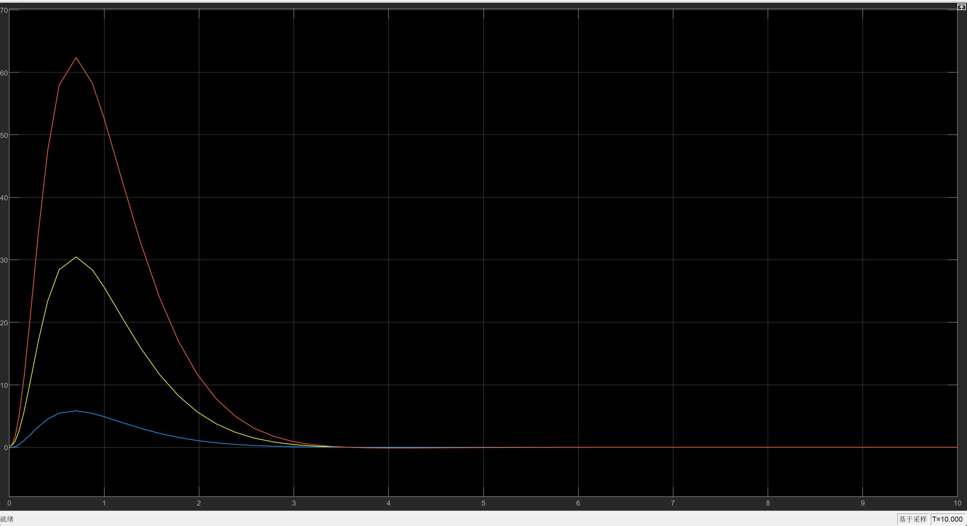

The six state responses with non-zero initial state but zero input is shown in Fig.

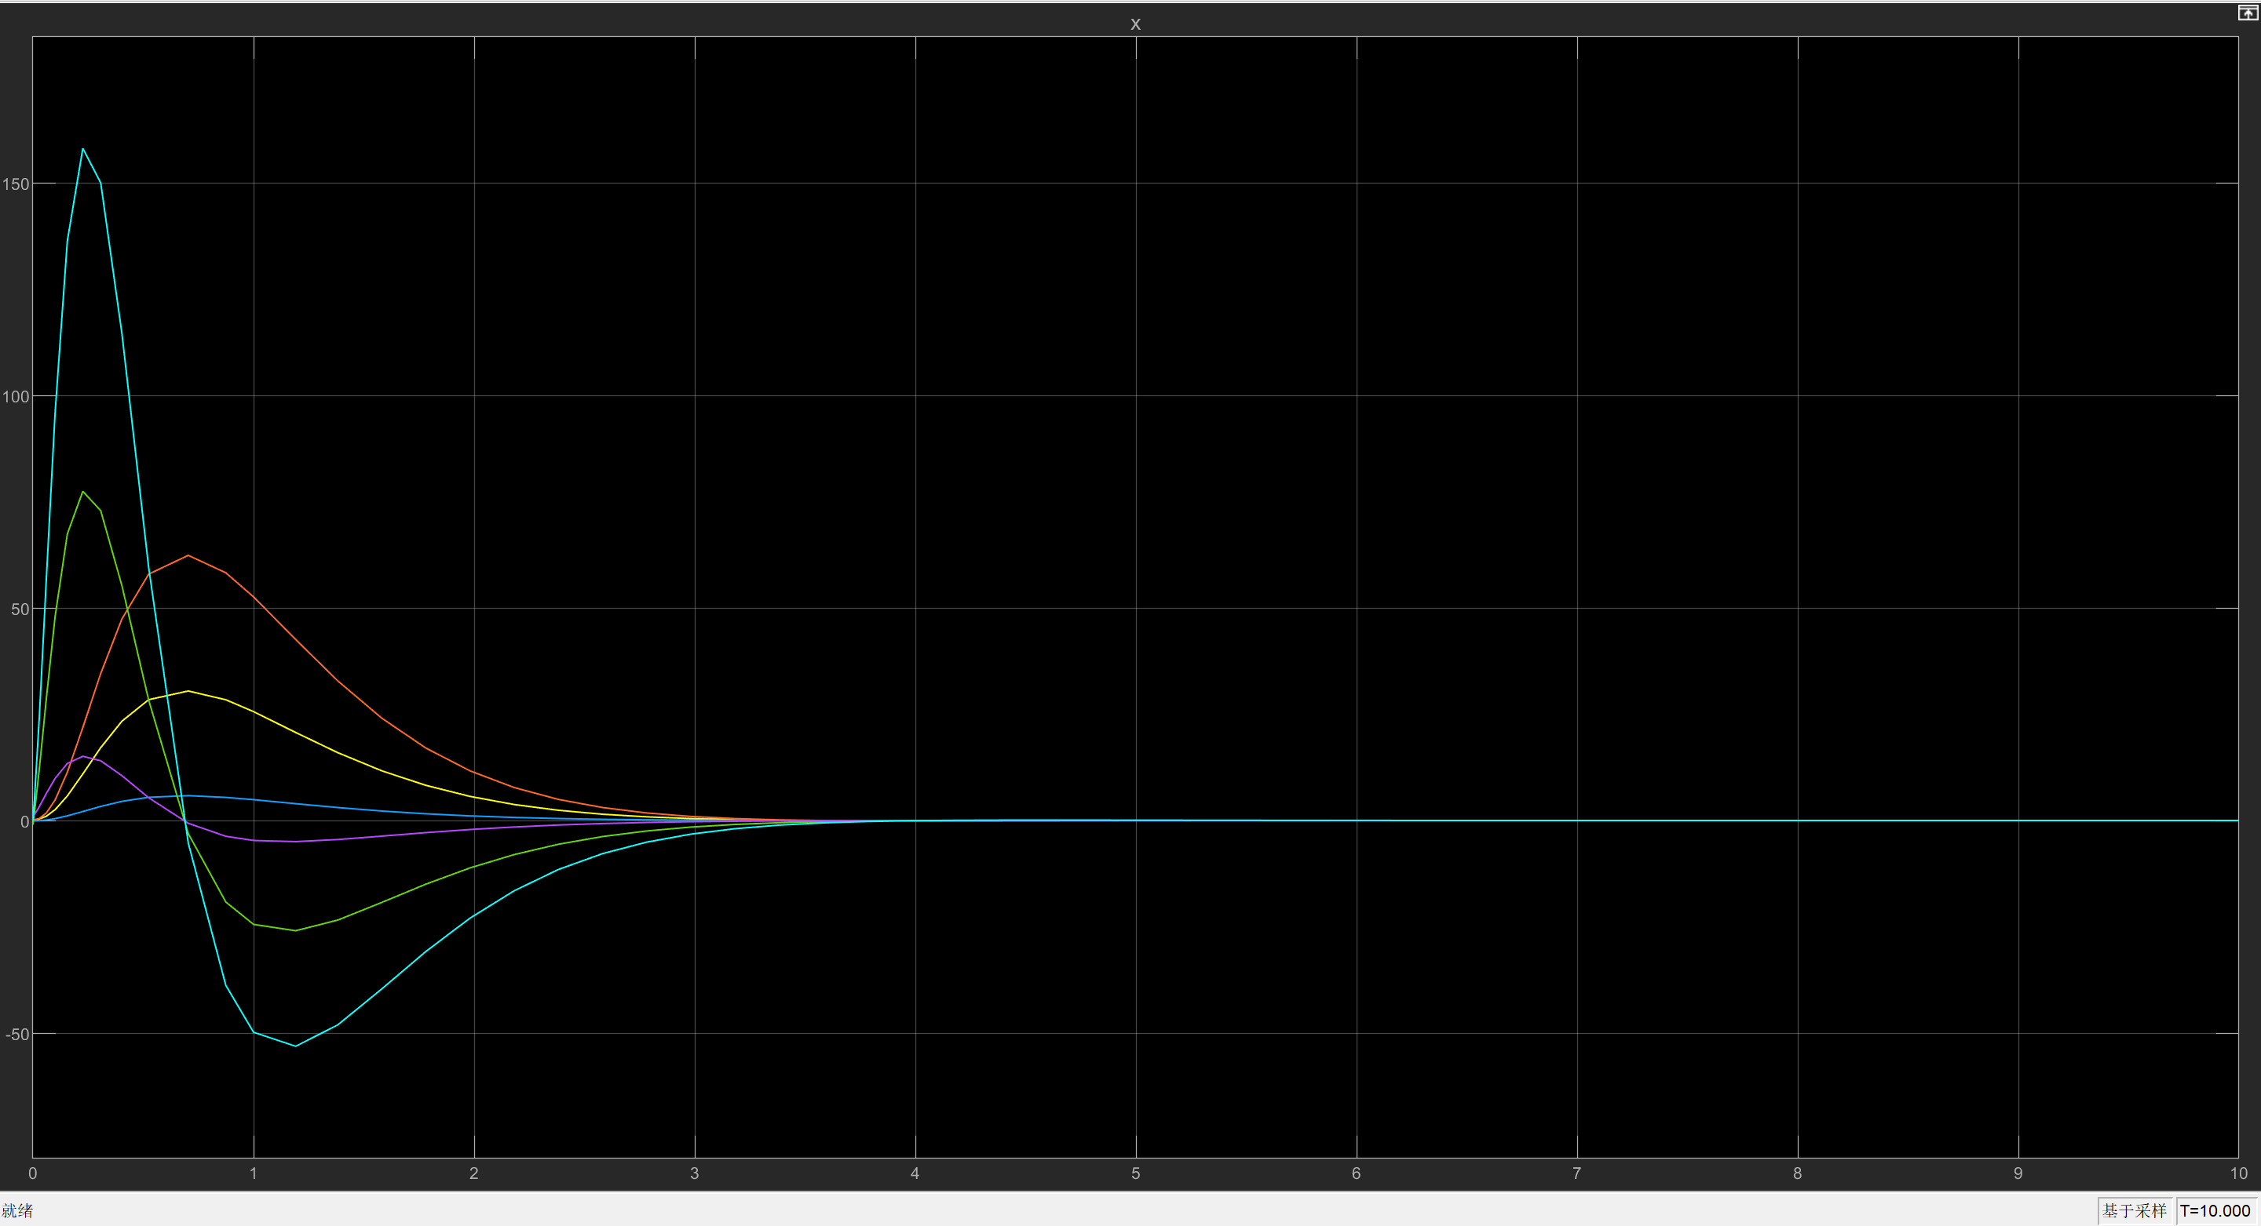

* + 1. **Position of Poles, System Performance and Control Signal Magnitude**

Choose different sets of stable poles as shown in Table to examine the effect of pole positions on the system performance and control signal magnitude.

For the system performance, it can be seen from Fig to Fig that when the dominant poles are farer from the original point in s-plane, the more stable the system transient response is. This is to say that the overshoot is lower with a shorter setting time.

As for the size of the control signal showing from Fig to Fig, the control signal size is smaller for a pole away from the origin of the s-plane.

|  |  |  |  |  |  |  |
| --- | --- | --- | --- | --- | --- | --- |
| Poles Sets |  |  |  |  |  |  |
| Set 1 | -1.8-0.872j | -1.8+0.872j | -6 | -7 | -8 | -9 |
| Set 2 | -1.6-1.2j | -1.6+1.2j | 7.04 | -7.36 | -7.68 | -8.0 |
| Set 3 | -1.2-1.6j | -1.2+1.6j | -4.8 | -5.4 | -5.76 | -6.0 |

Set 1: 1.8:

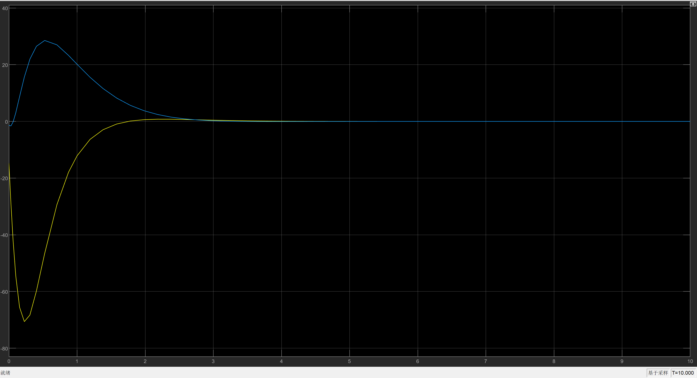

Set 2: 1.6:

performance:

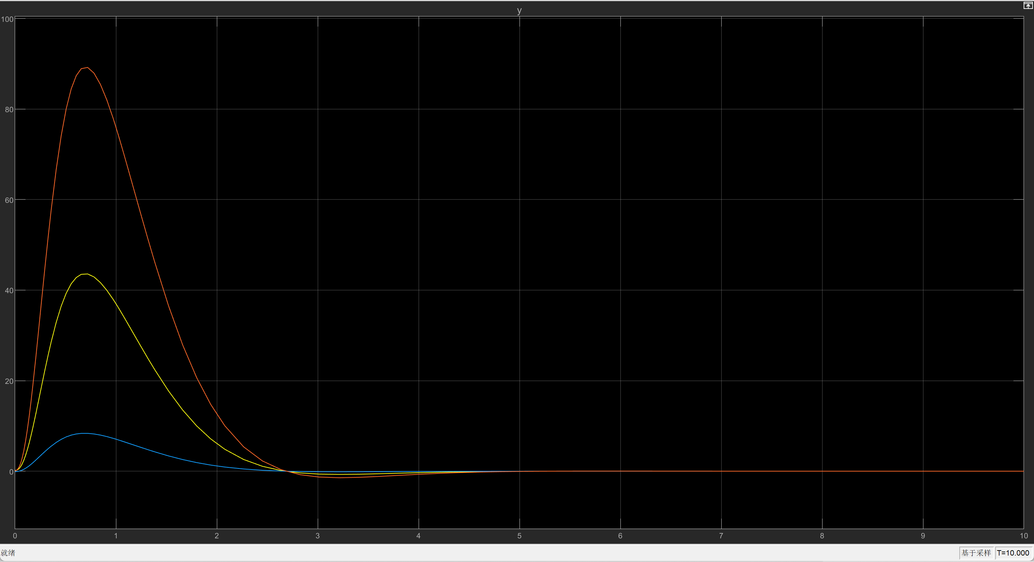

X:

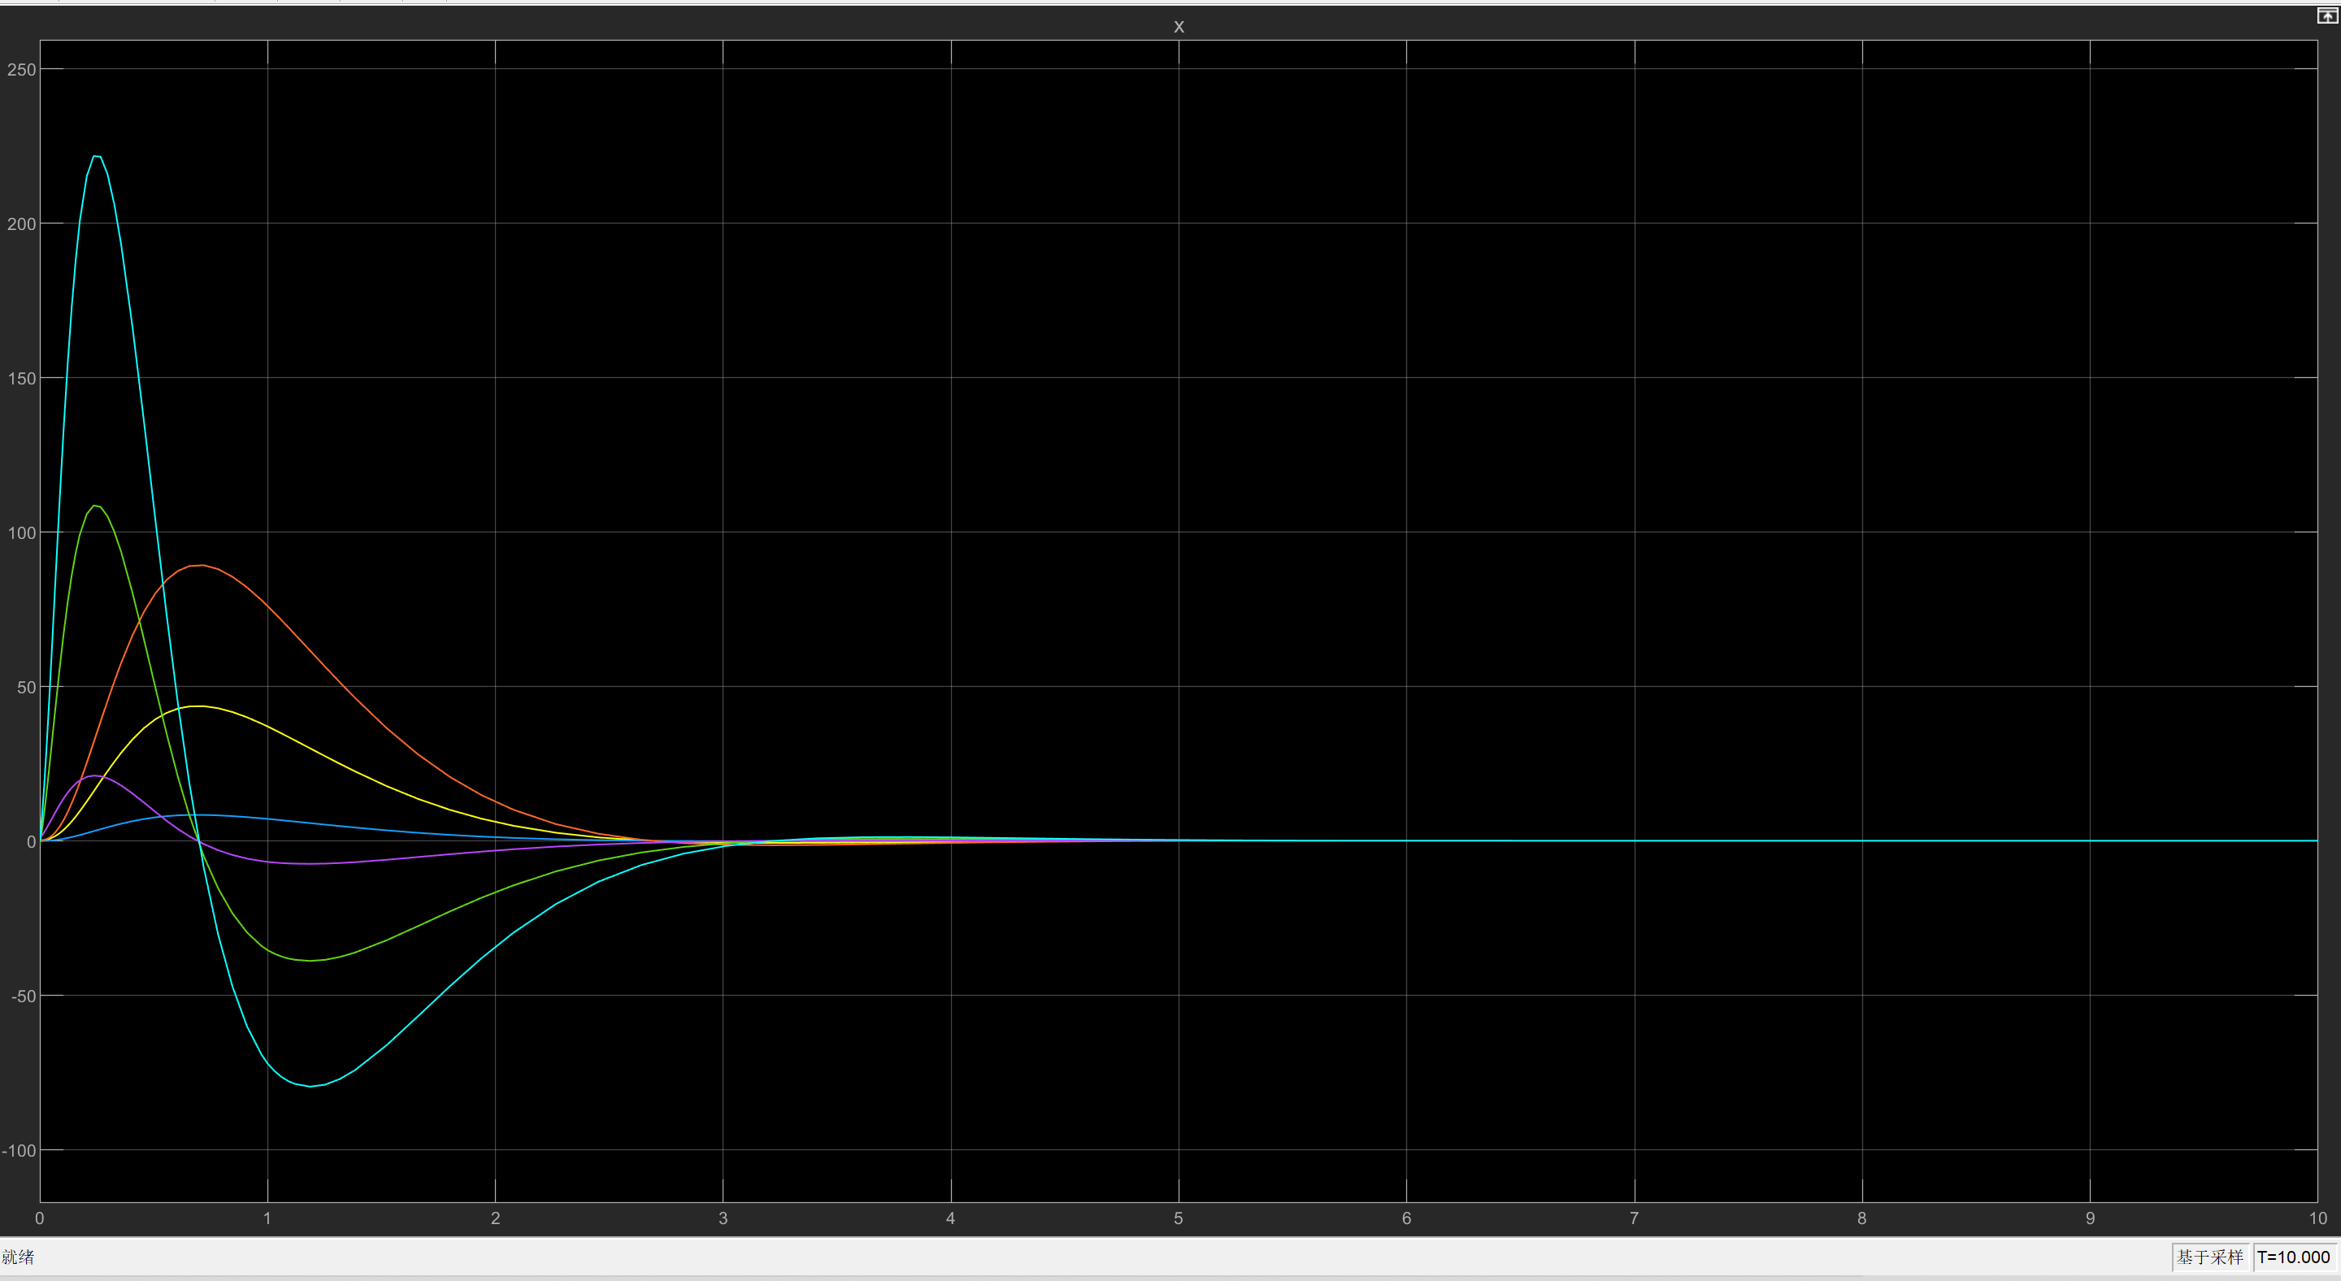

Control size:

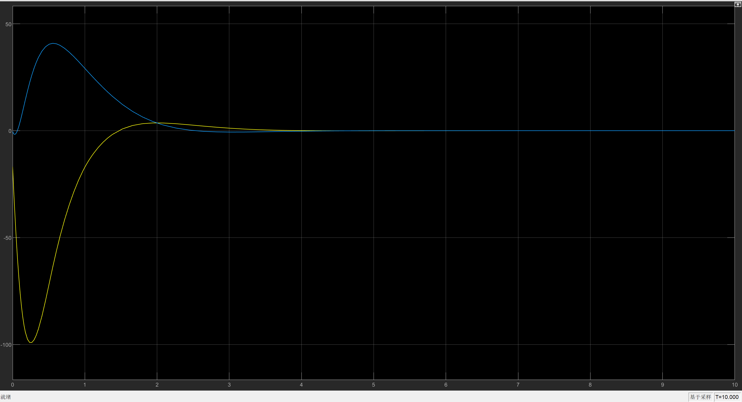

Set 3: 1.5

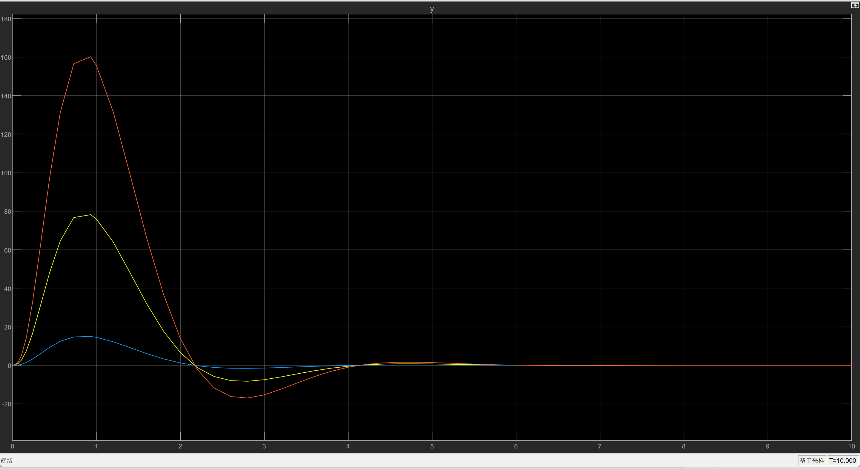

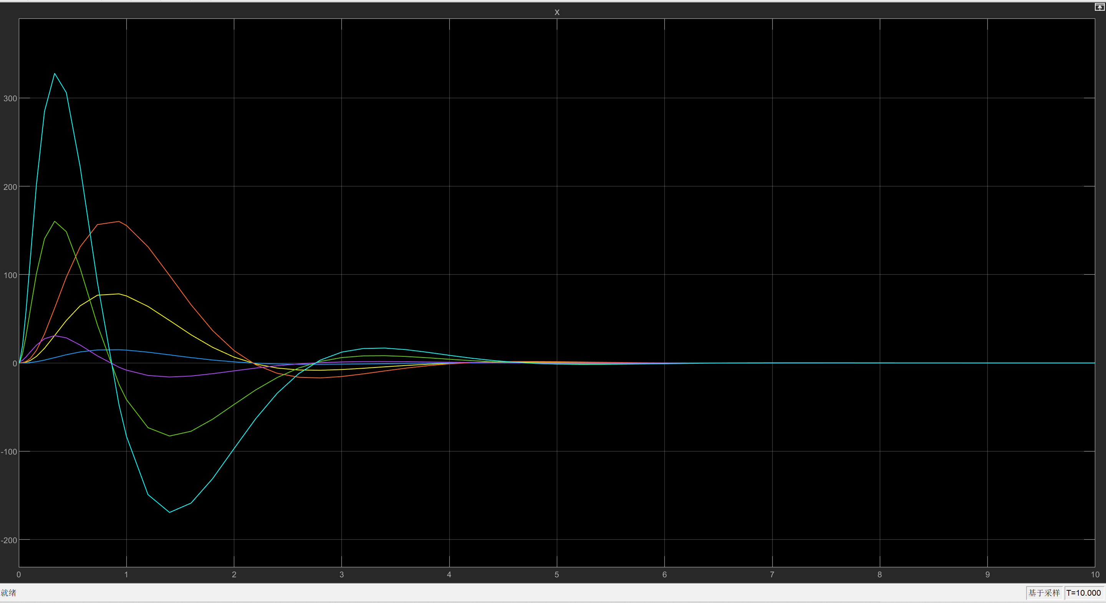

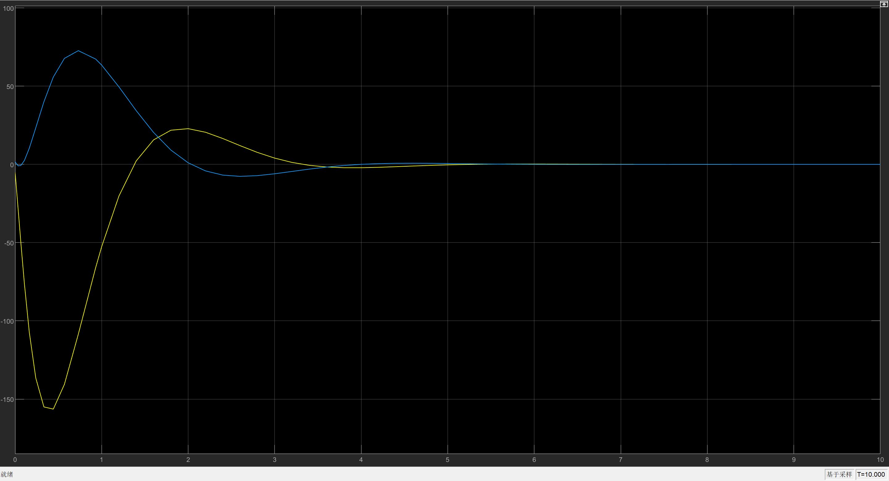

* 1. **Control By All State Variables Using LQR**
     1. **Controller Design**

To design an LQR controller, the weighting matrices and must be chosen first. Choose Q to be the semi-positive definite matrix in Equation and R to be the positive definite matrix in Equation.

Use state feedback controller , then the feedback gain is given by Equation:

where can be retrieved by solving the ARE.

To solve the ARE by programming method, it is better to use the eigenvalues-eigenvector method. Construct matrix as in Eq

With and , then matrix can be obtained as in Fig.

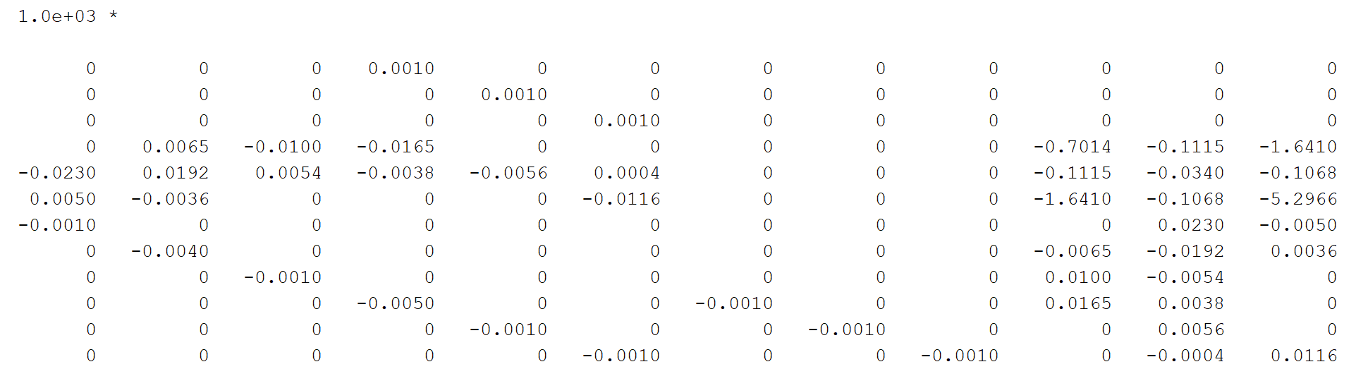

Get the eigenvalues and eigenvectors. For all of the eigenvectors, choose the ones corresponding to stable eigenvalues. And form them into a matrix where each column is a stable eigenvector as in Figure.

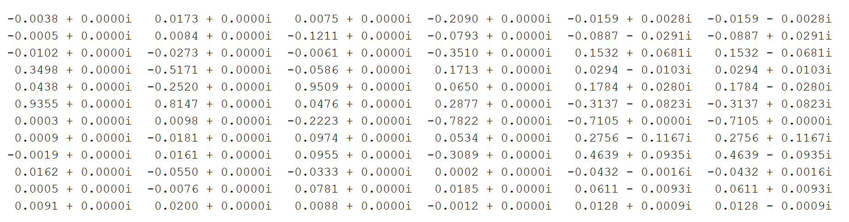

Split the matrix formed by eigenvectors vertically to get two matrices and . Then

Finally, with , the result of the feedback gain is shown in Figure.

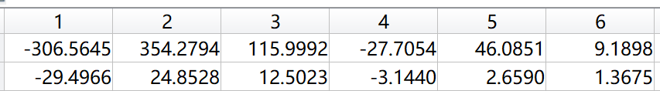

The overall feedback system design is illustrated in Fig.

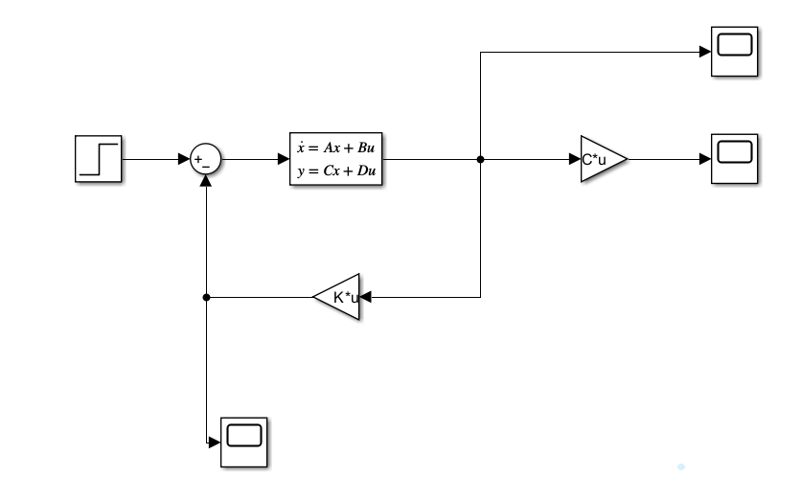

* + 1. **Simulation Results**

The transient response of the system is shown in Fig. It can be seen that the choice of weightings gives a stable system that satisfies the general requirements.

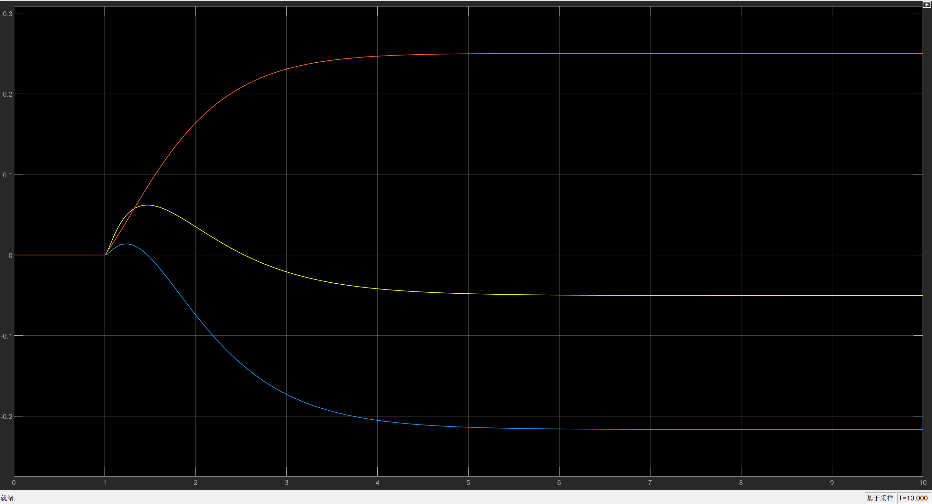

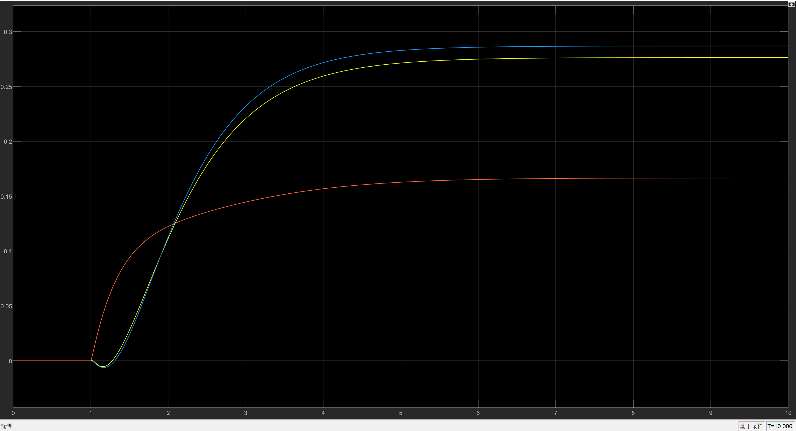

The simulation result for initial state and zero input is as shown in Fig and Fig:

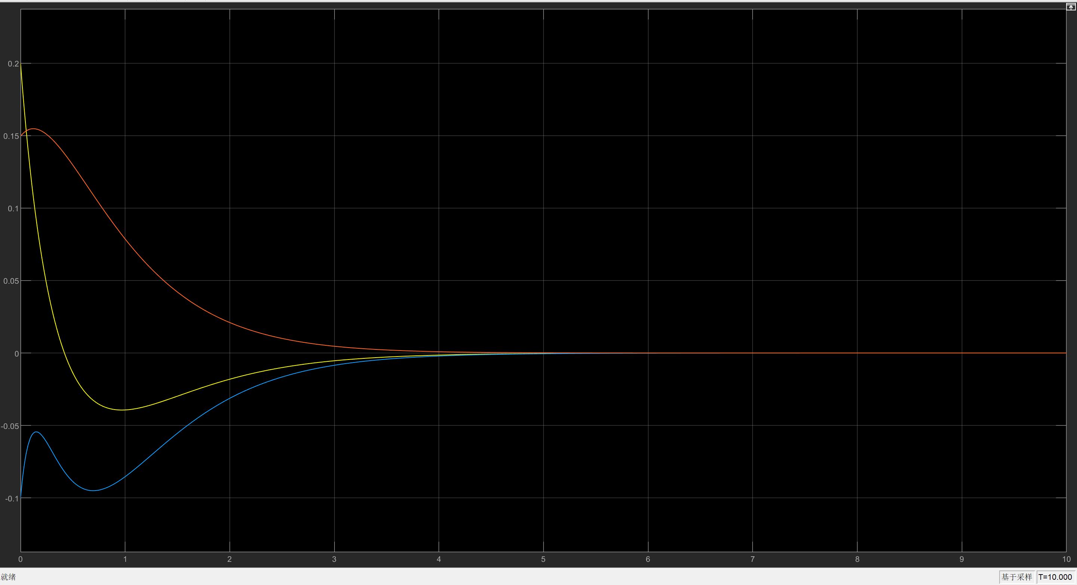

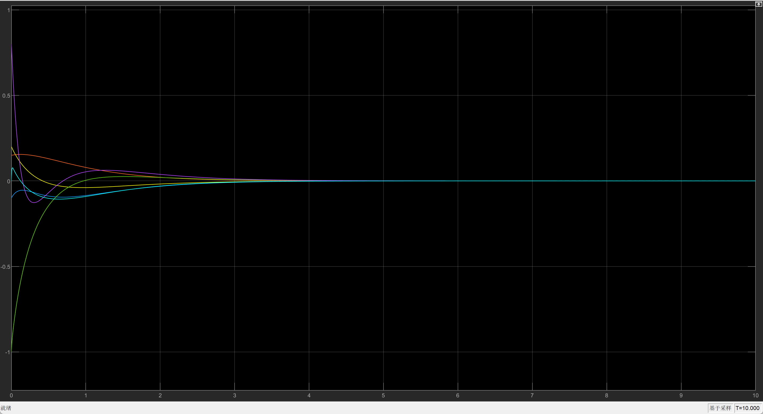

K3:

Performance:

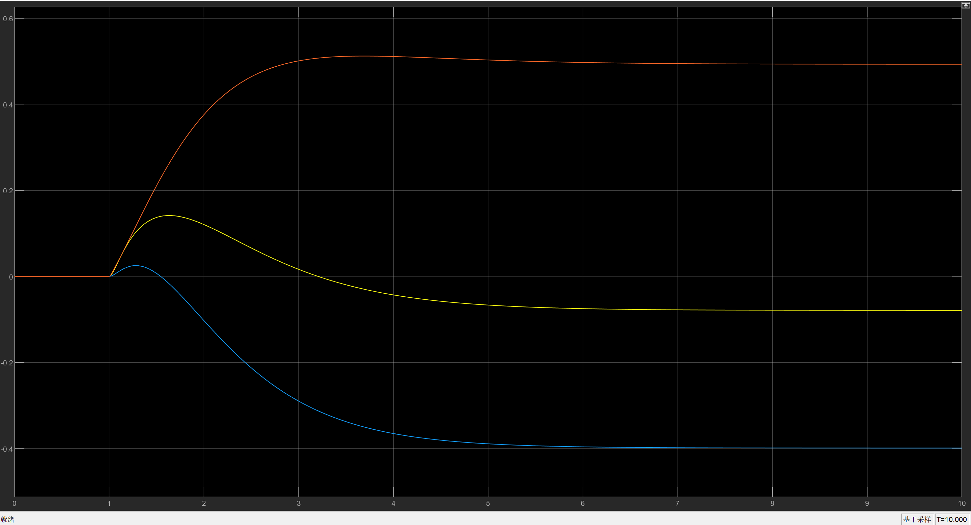

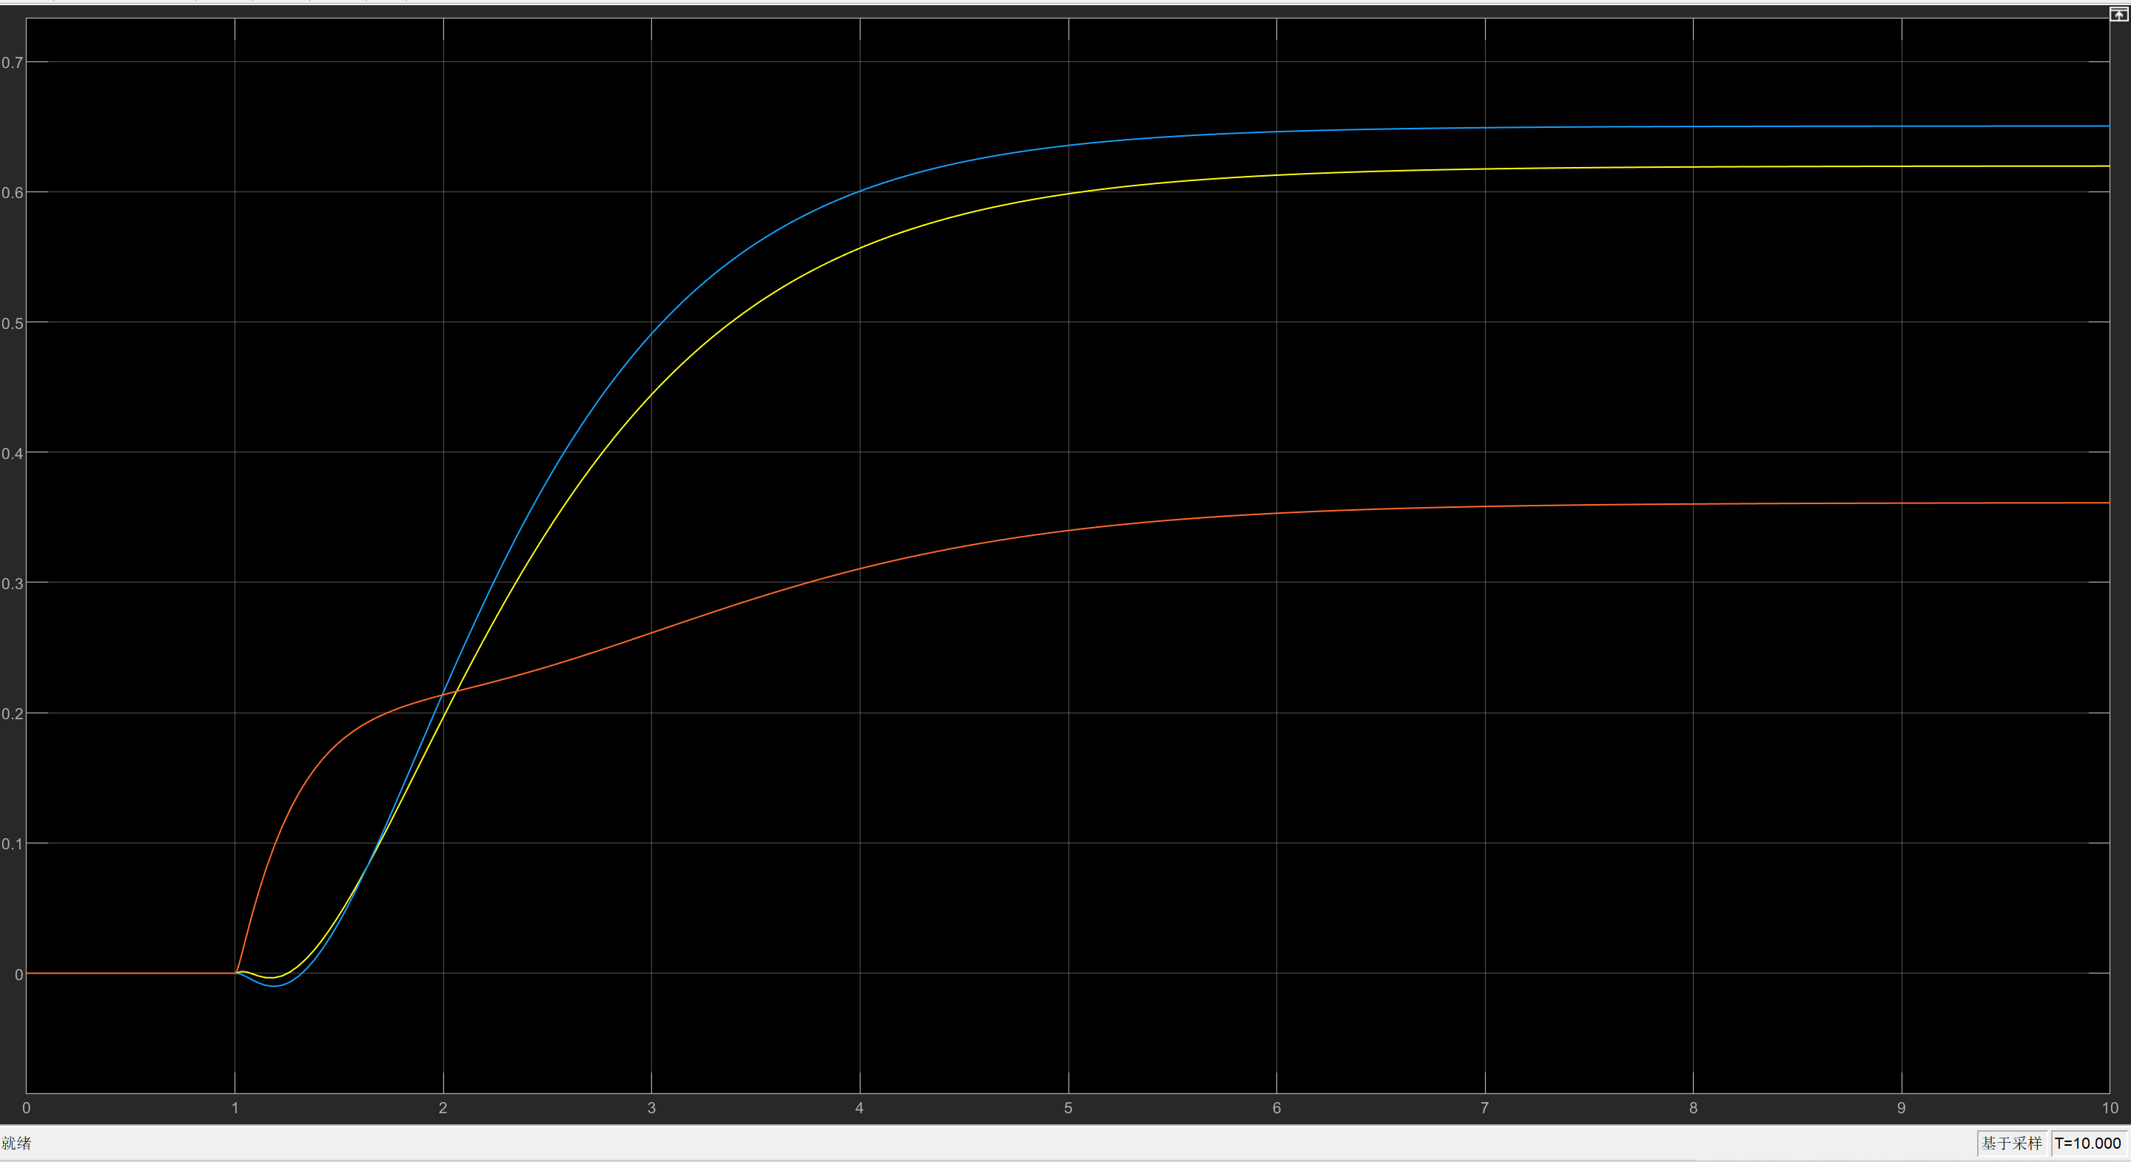

States:

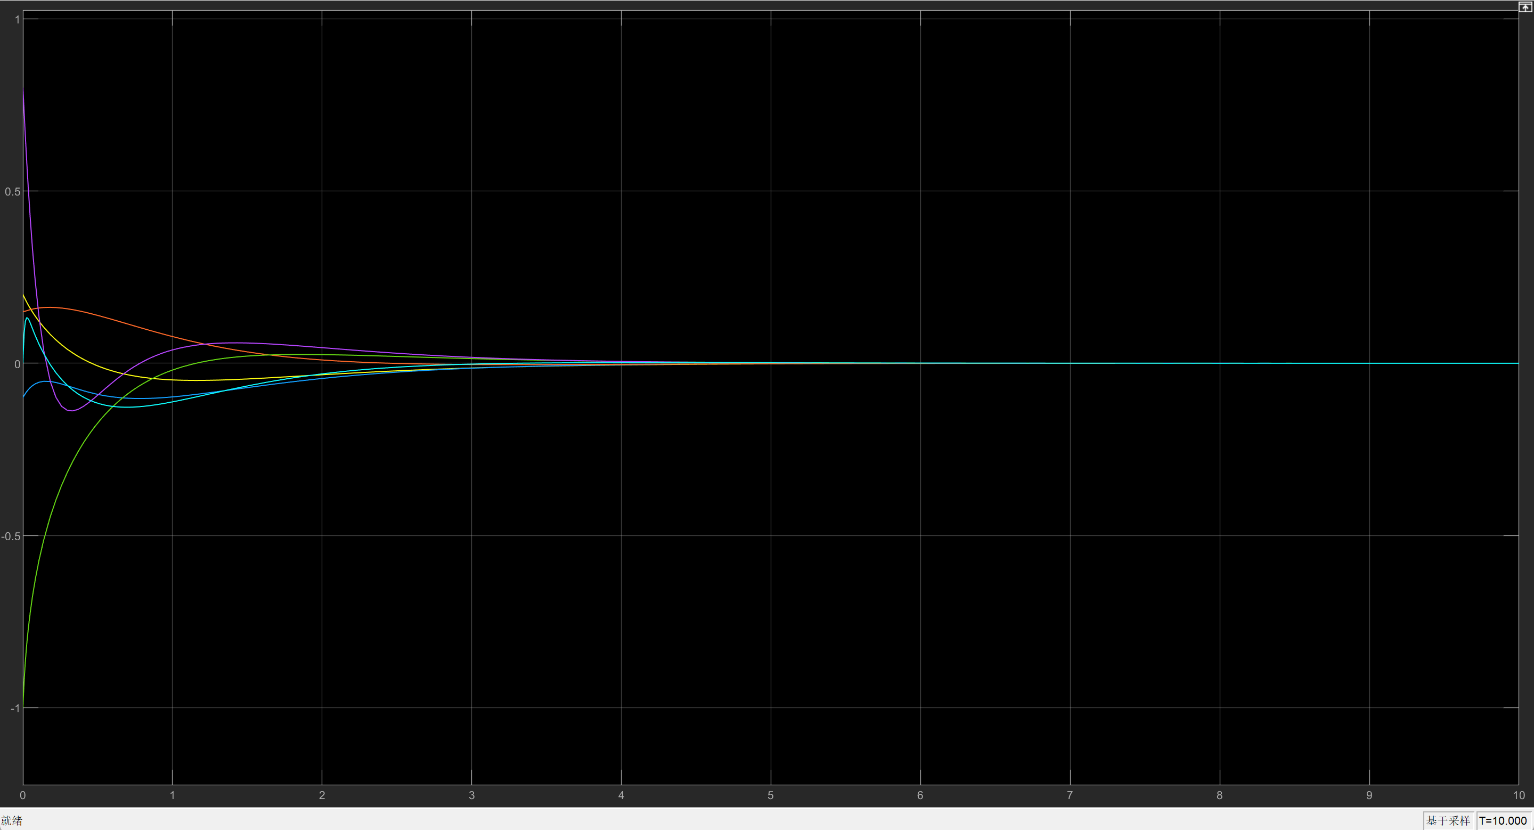

Control:

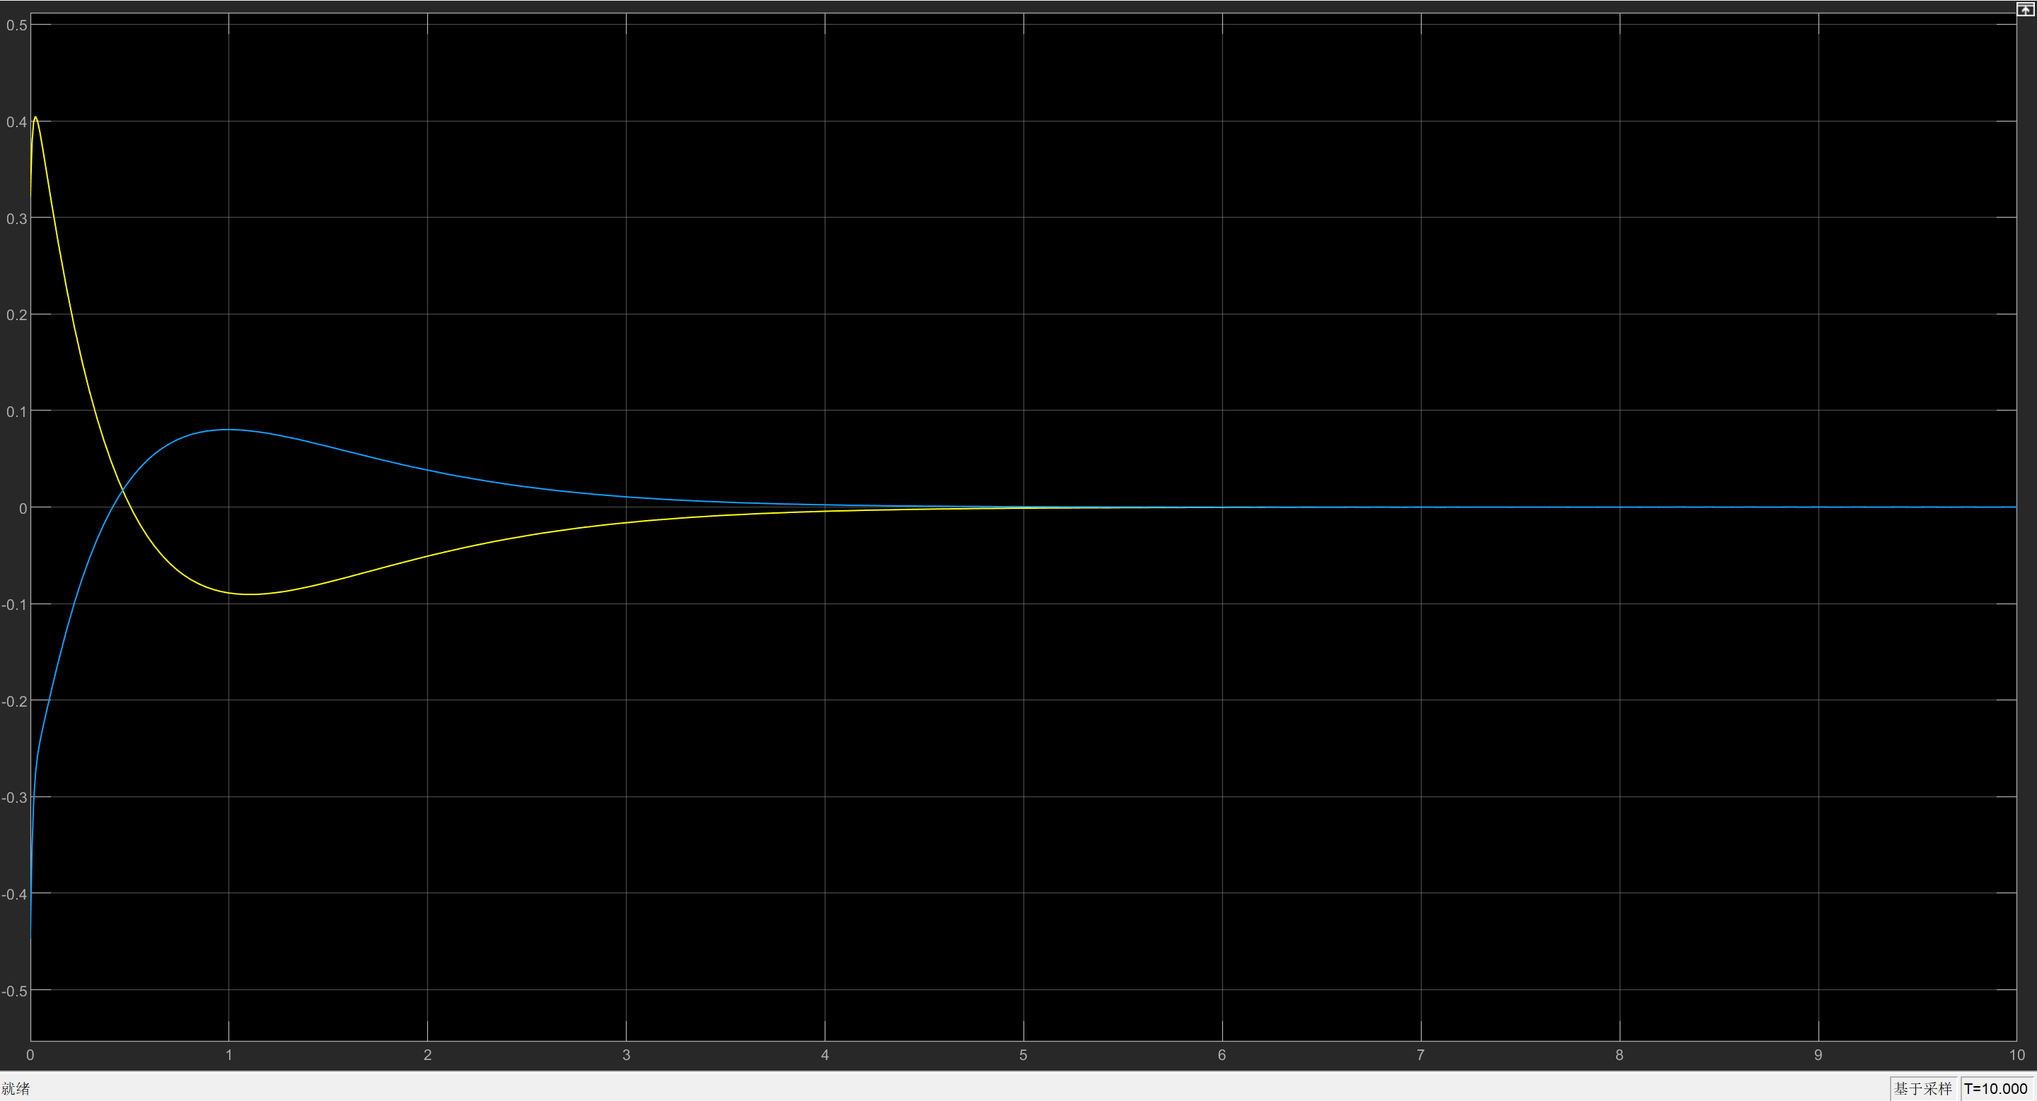

* + 1. **The Effect of Weightings Q and R on System Performance and Control Signal Magnitude**

For a bigger weight on the state variables, the output response is smaller, but with a similar overshoot and settling time. A smaller control signal is also seen in this case.

For a bigger weight on the input, the output response is also smaller, but with a similar control signal.

K1: control signal Size:

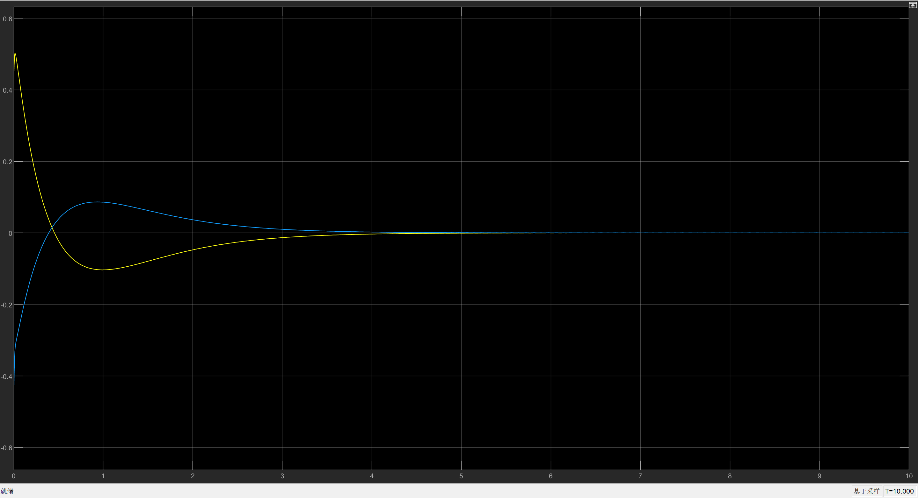

k2: performance:

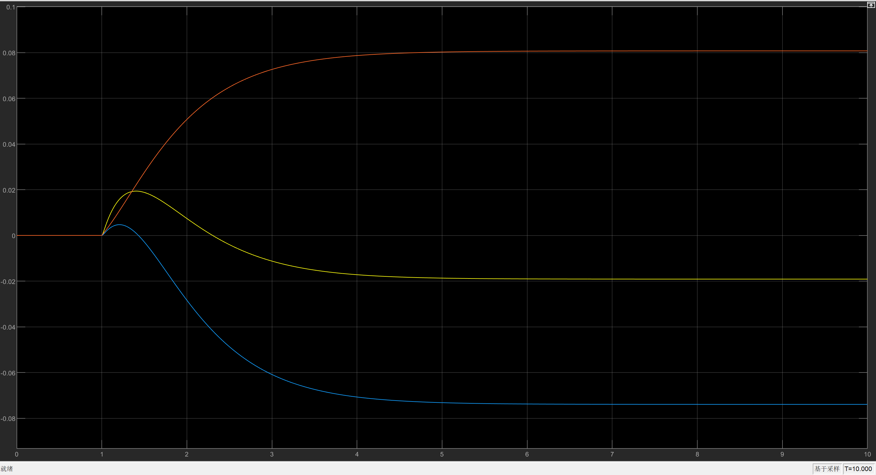

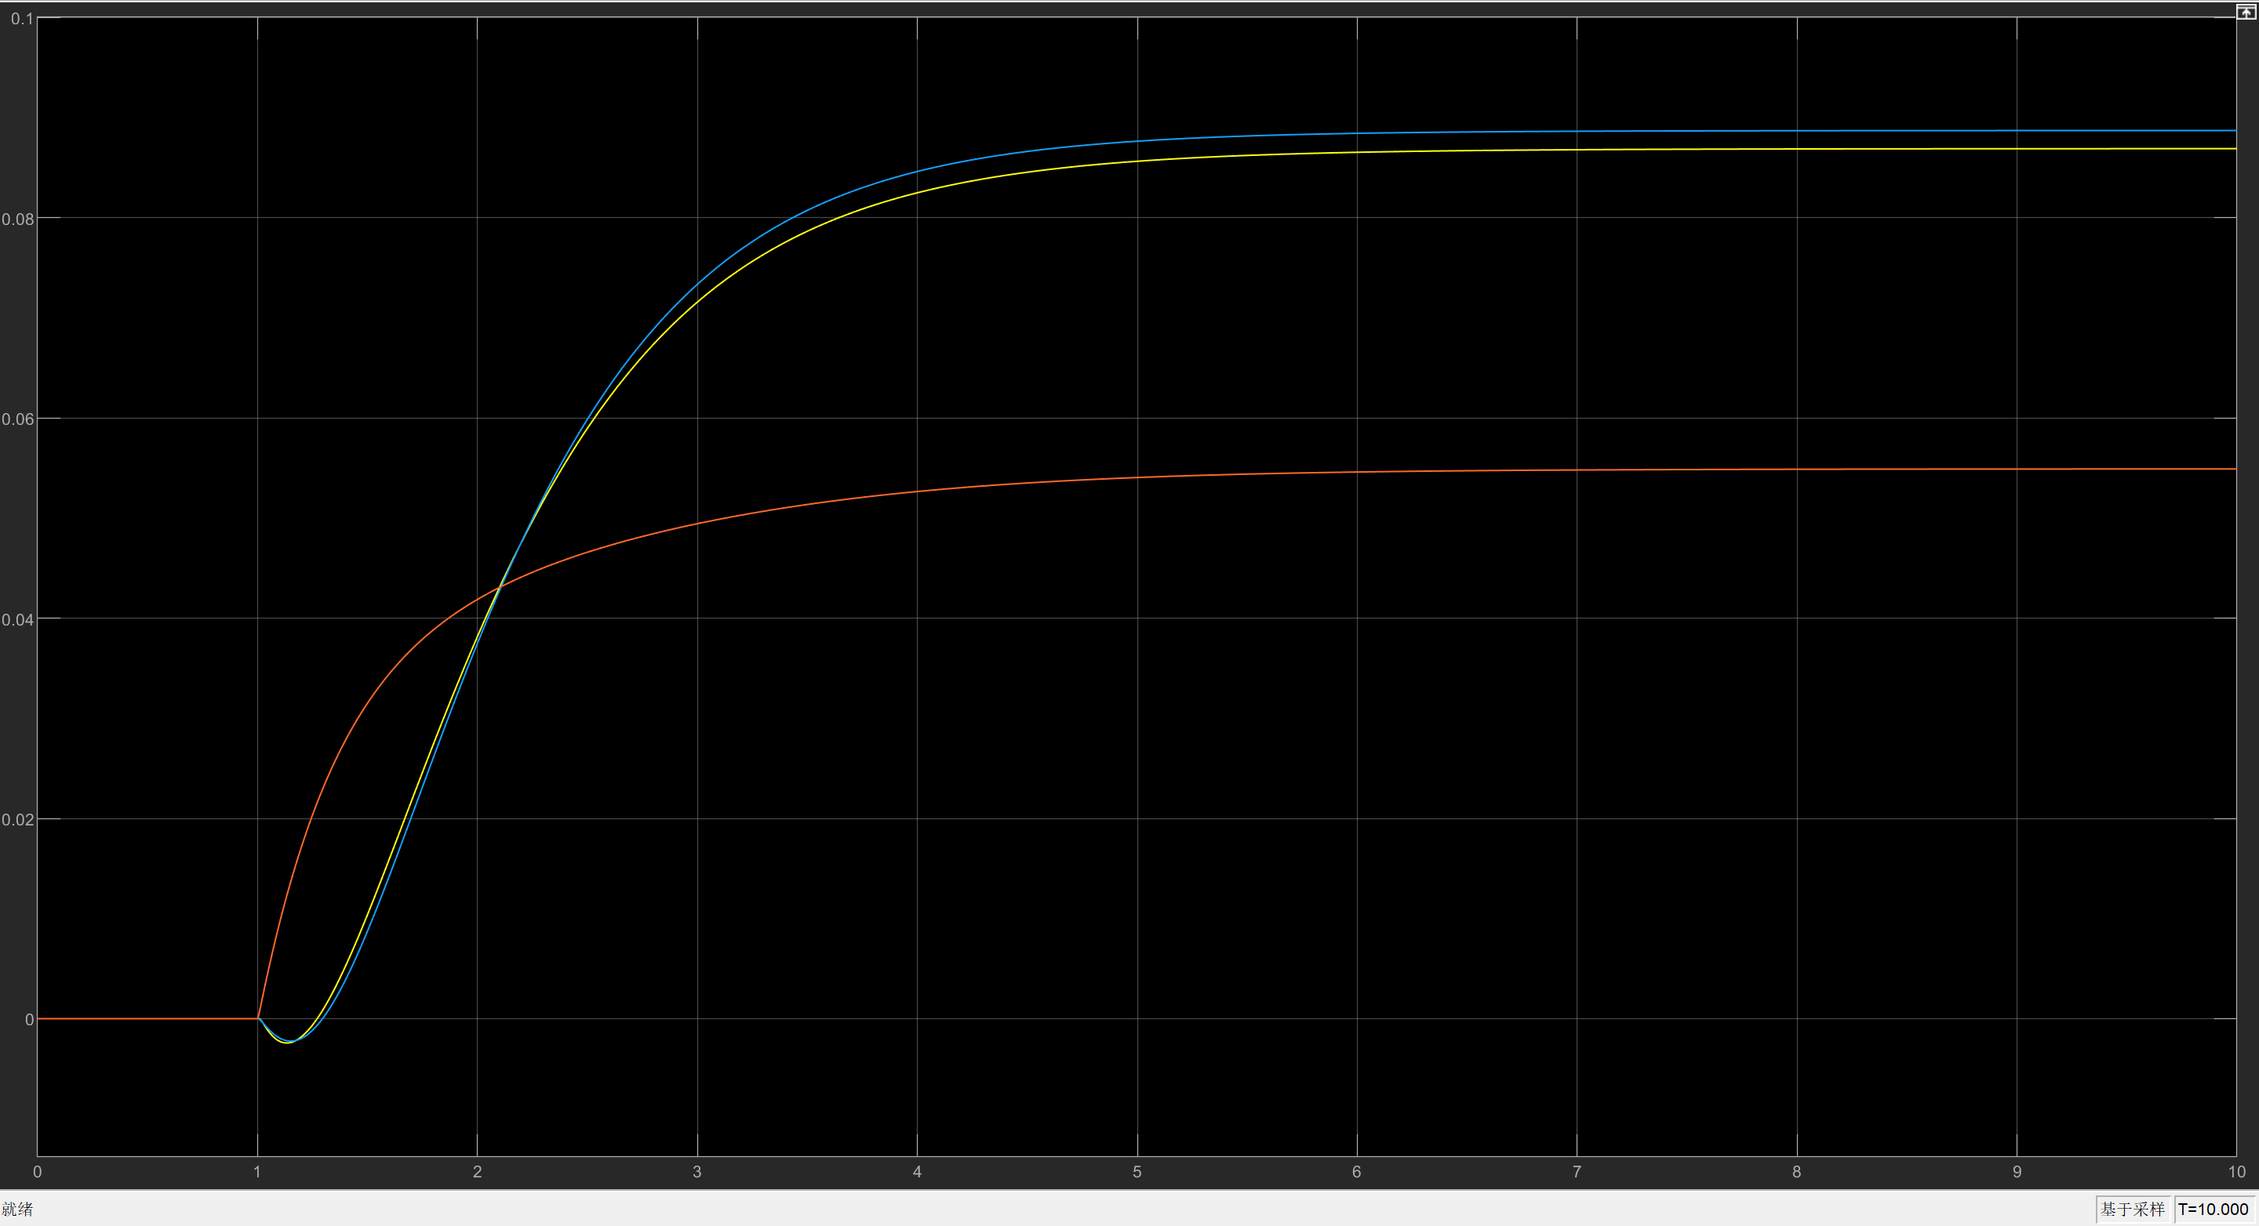

Control signal size:

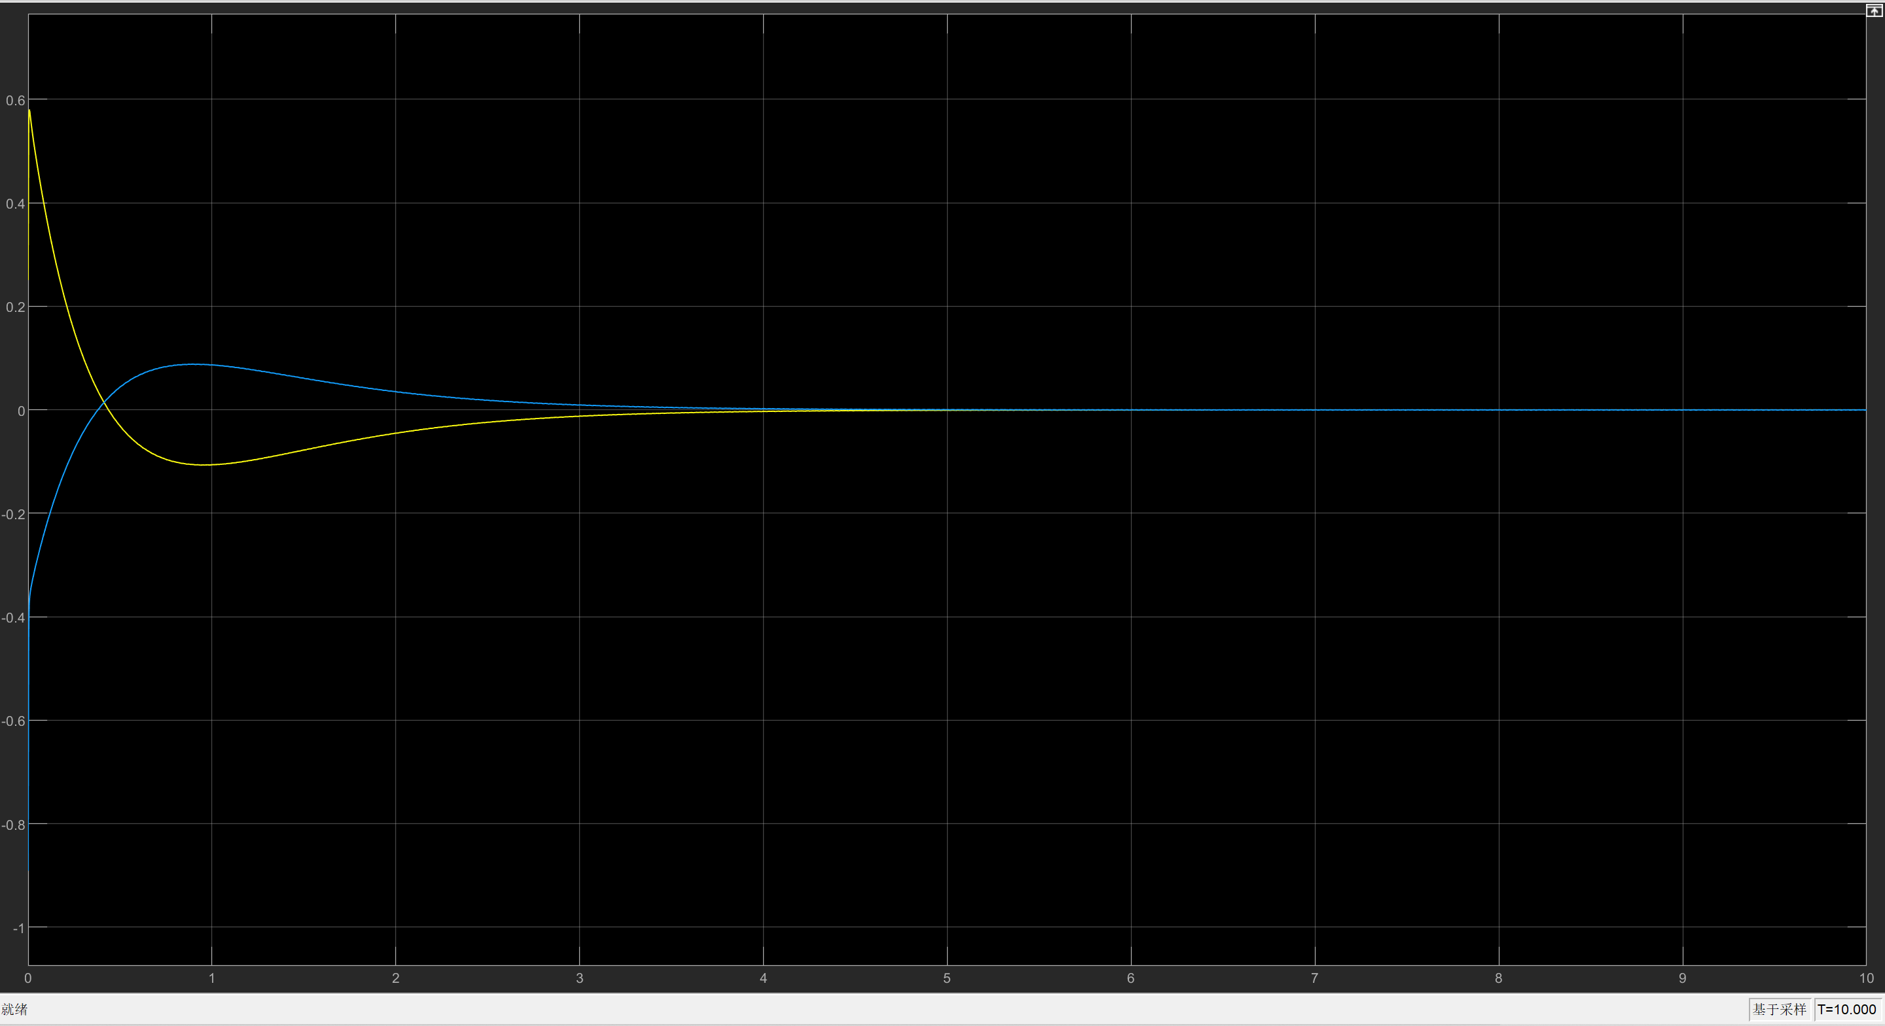

* 1. **State Estimation with All Output**
     1. **Observer Design**

The system to be observed is the feedback system designed in task 2, with and given by Equation.

Full order method is used to design the observer. Set the output error gain to be . Then an that stabilizes the error can be computed by , where is the state feedback gain of the dual system of the original system. The state feedback gain of the dual system is obtained by full-rank method of pole placement introduced previously in section 1.1.1. Set the poles to be that displayed in Table, then the values in are displayed in Fig.

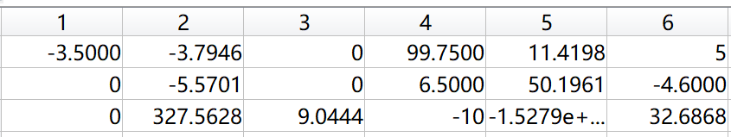

For this , one can get the observer gain as in Fig.

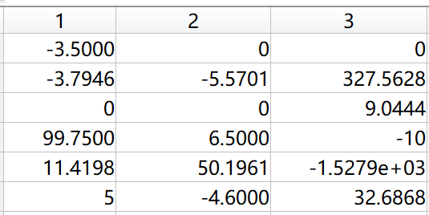

The overall system design is shown in Fig.

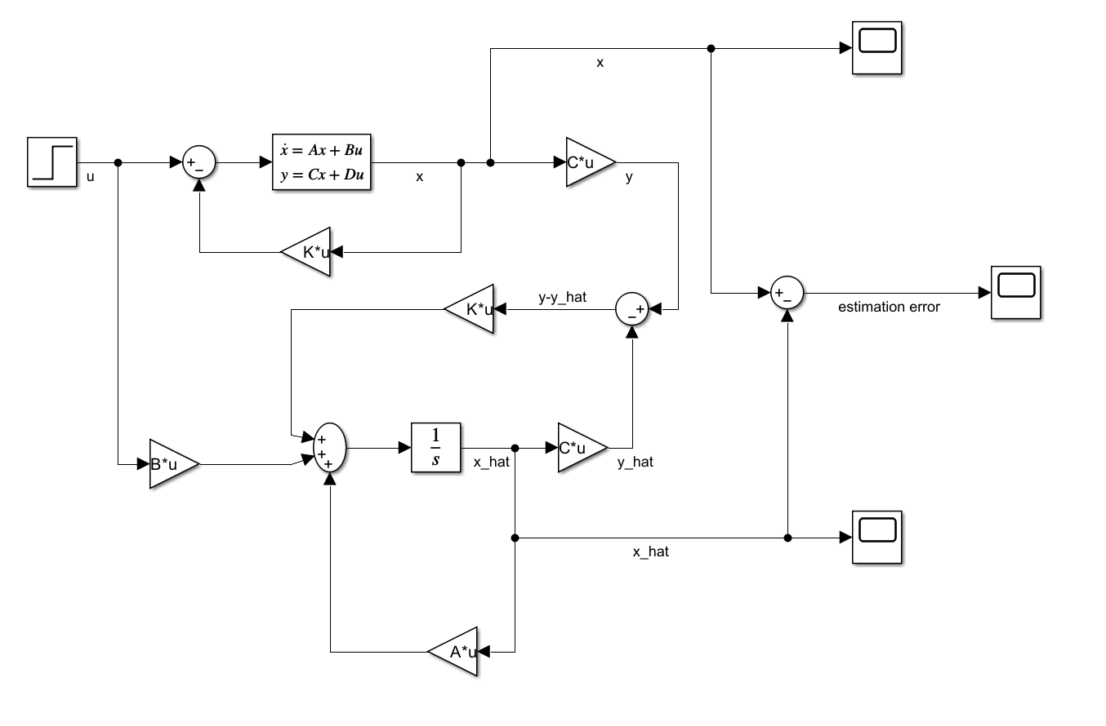

* + 1. **Simulation Results**

The simulation result for the estimation error with initial state and zero input is as shown in Fig. This result shows that the observer can drive the state estimation error to 0.

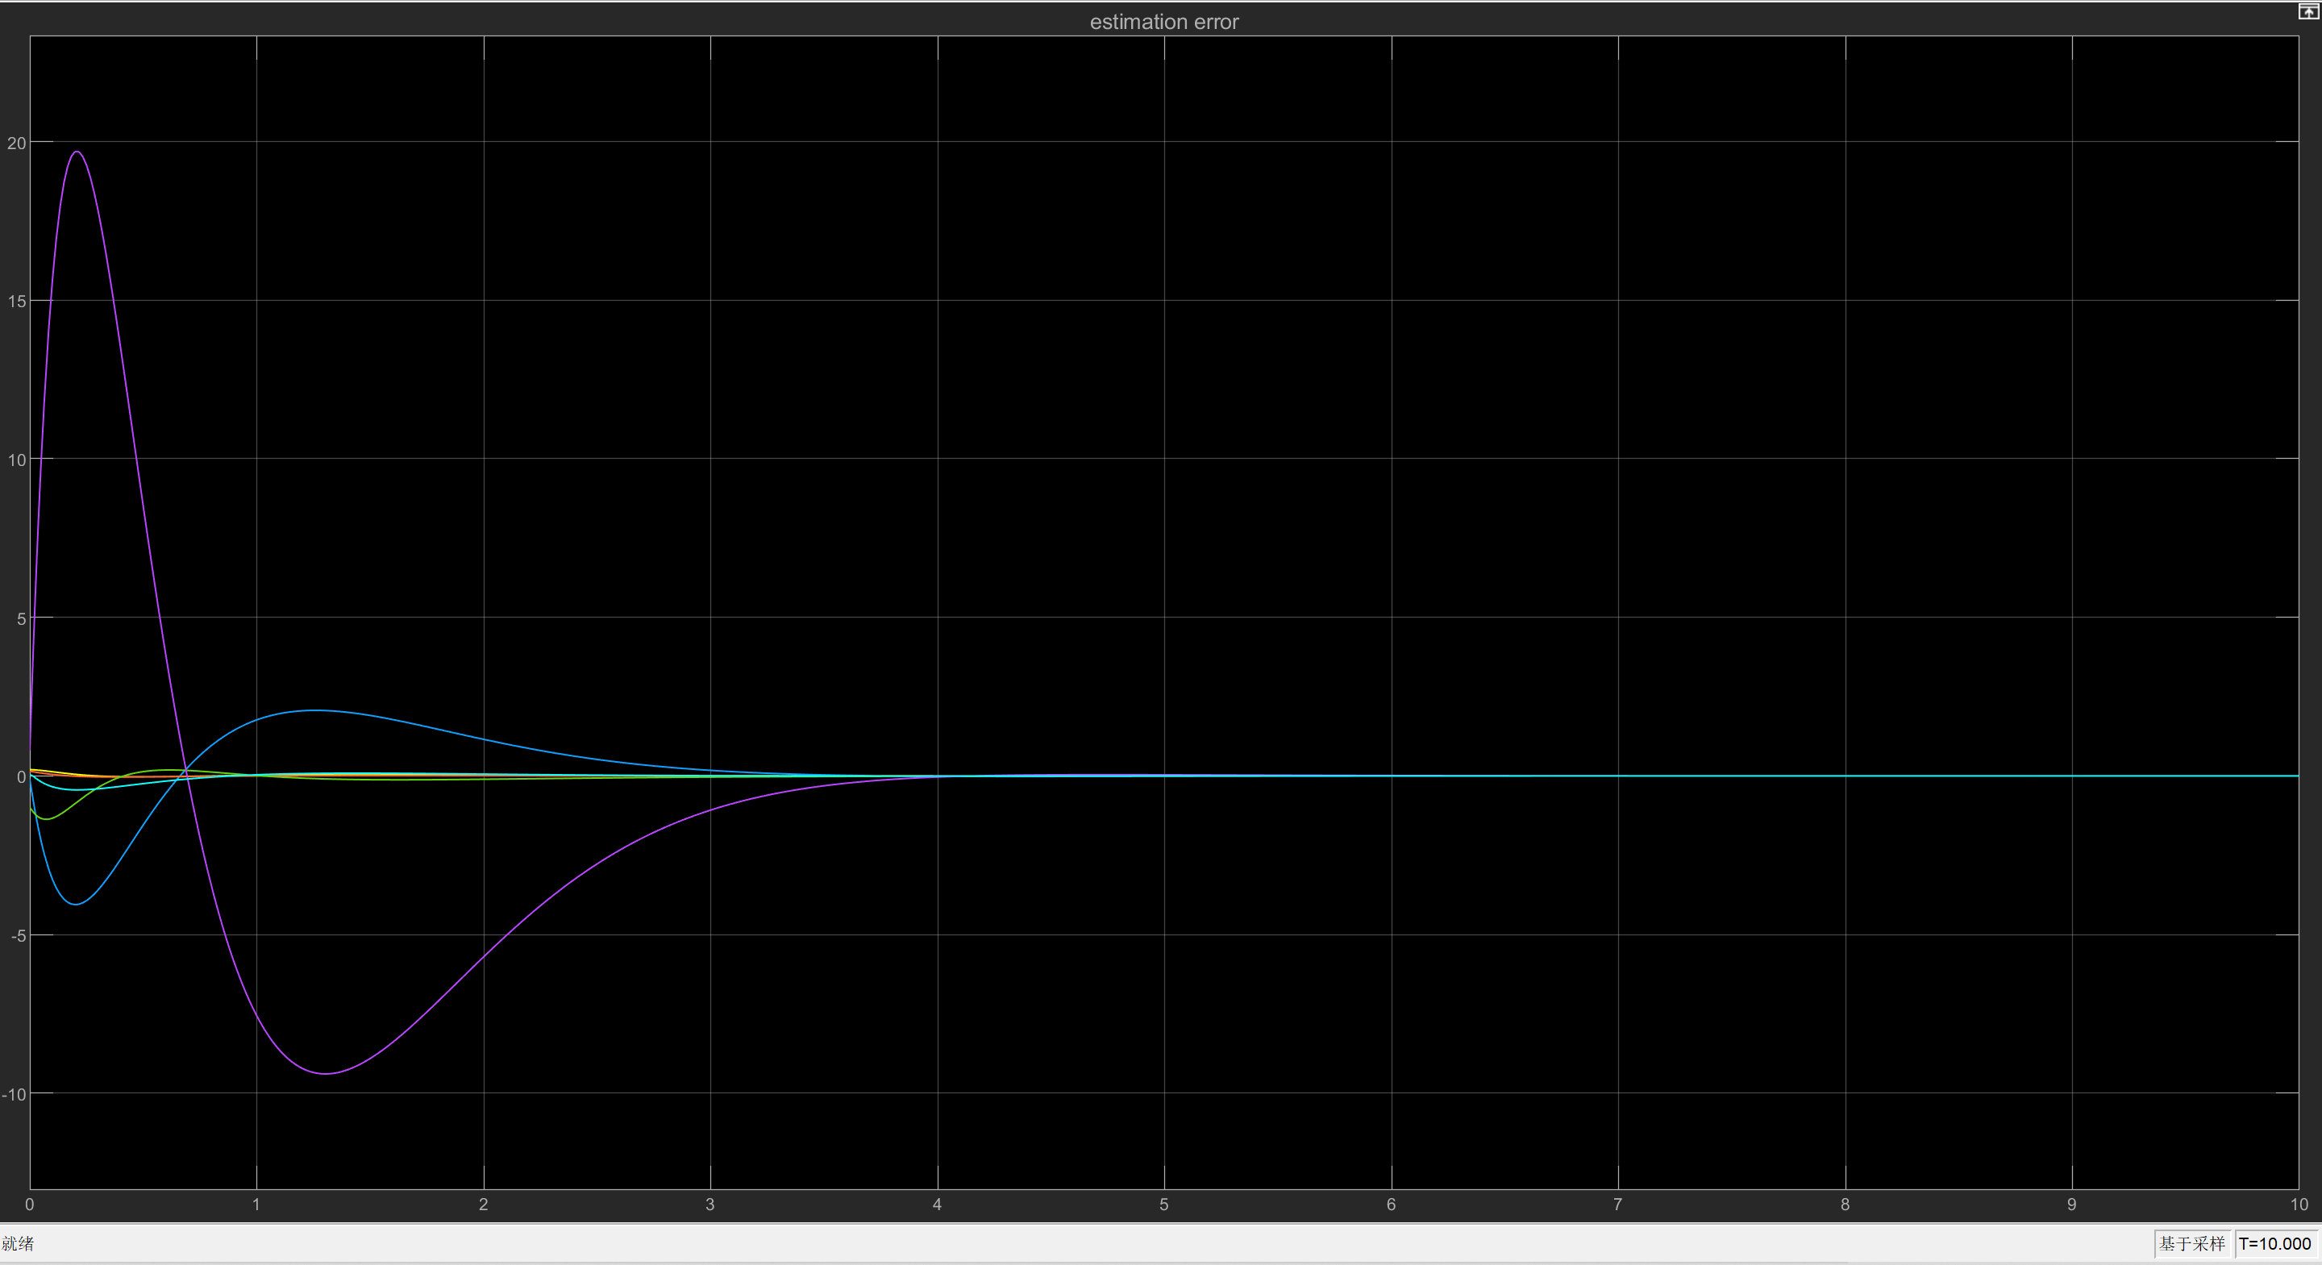

* + 1. **The Effect of Observer Poles on State Estimation Error and Closed-Loop System Performance**

When the observer poles are away from the s-plane origin, the state estimation error converges faster to zero than when they are closer to the origin. Other than this, compared to the system performance in task 2, the output is more stable and converges quicker when using state estimators.

Poles 1:

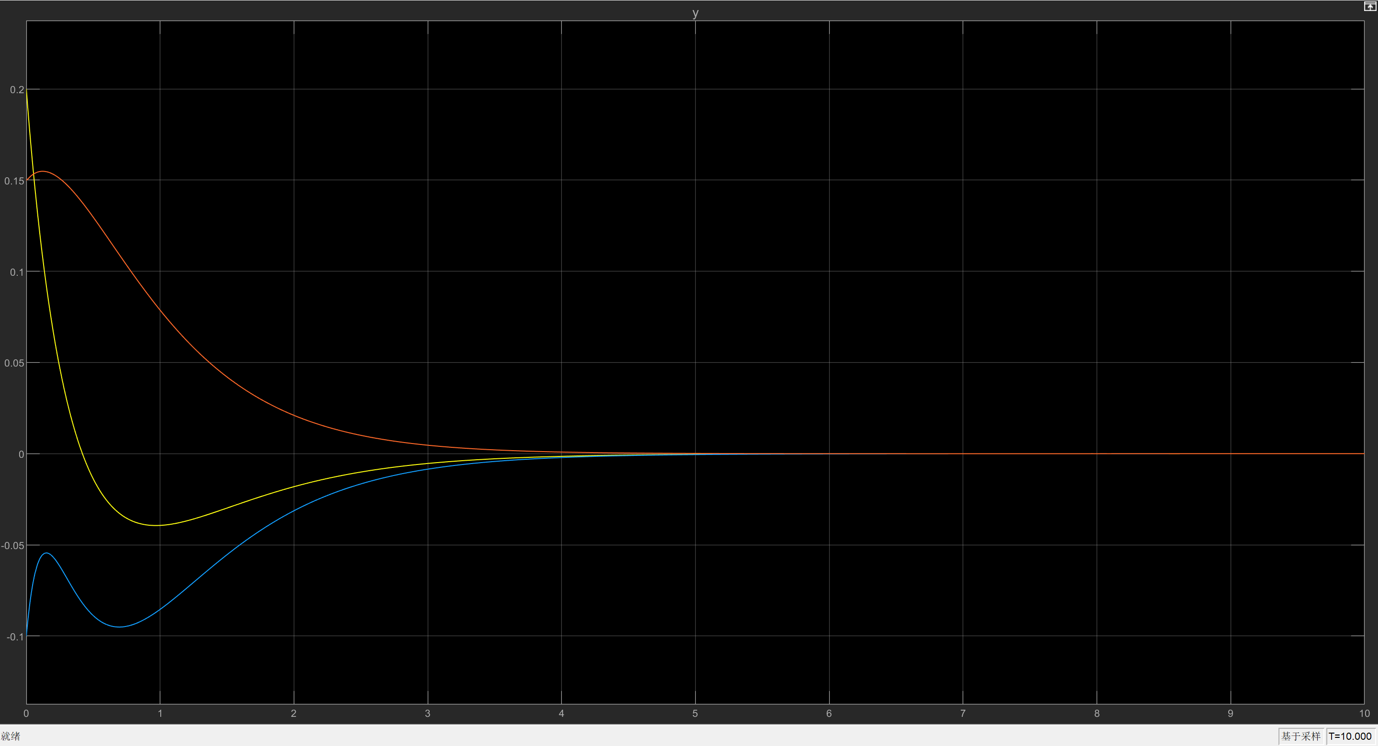

Poles 2:

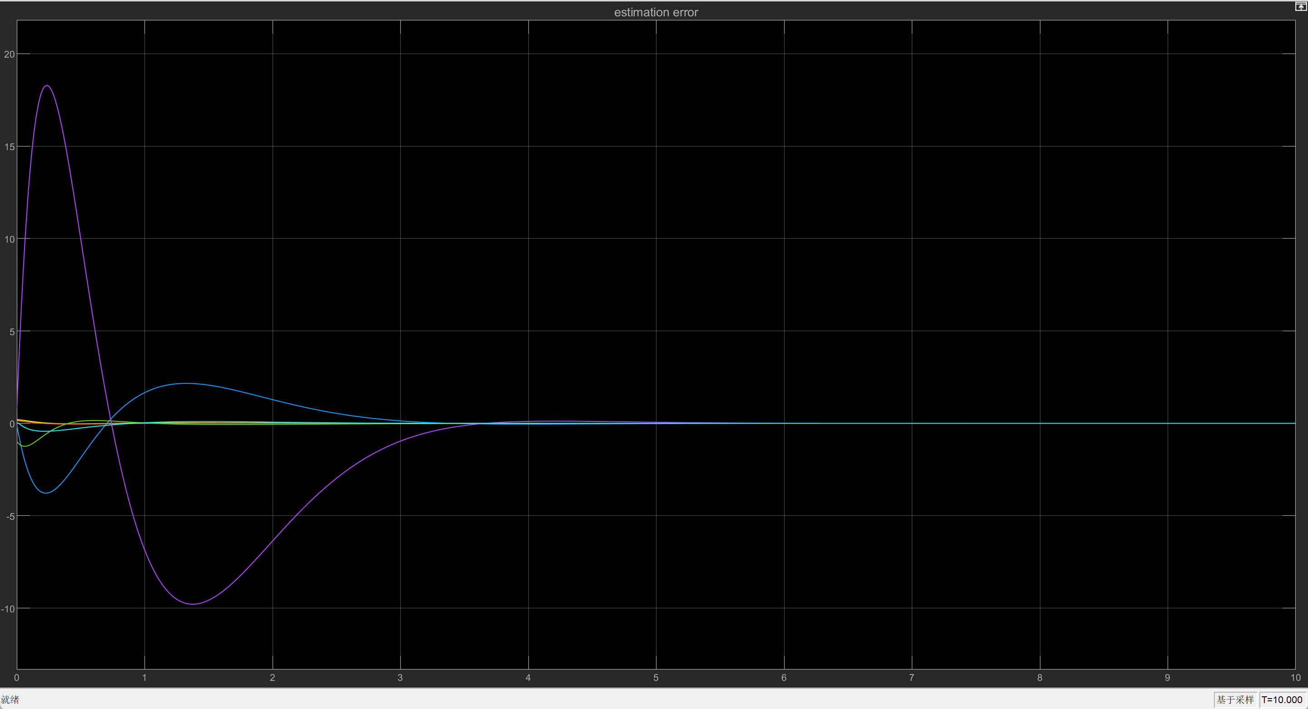

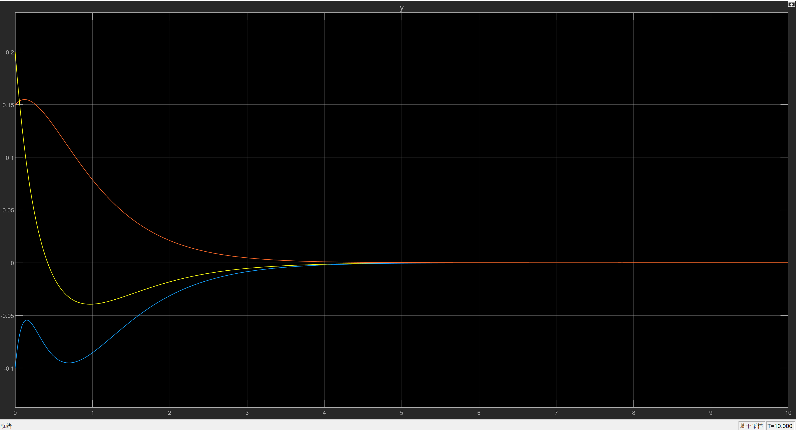

Poles 4:

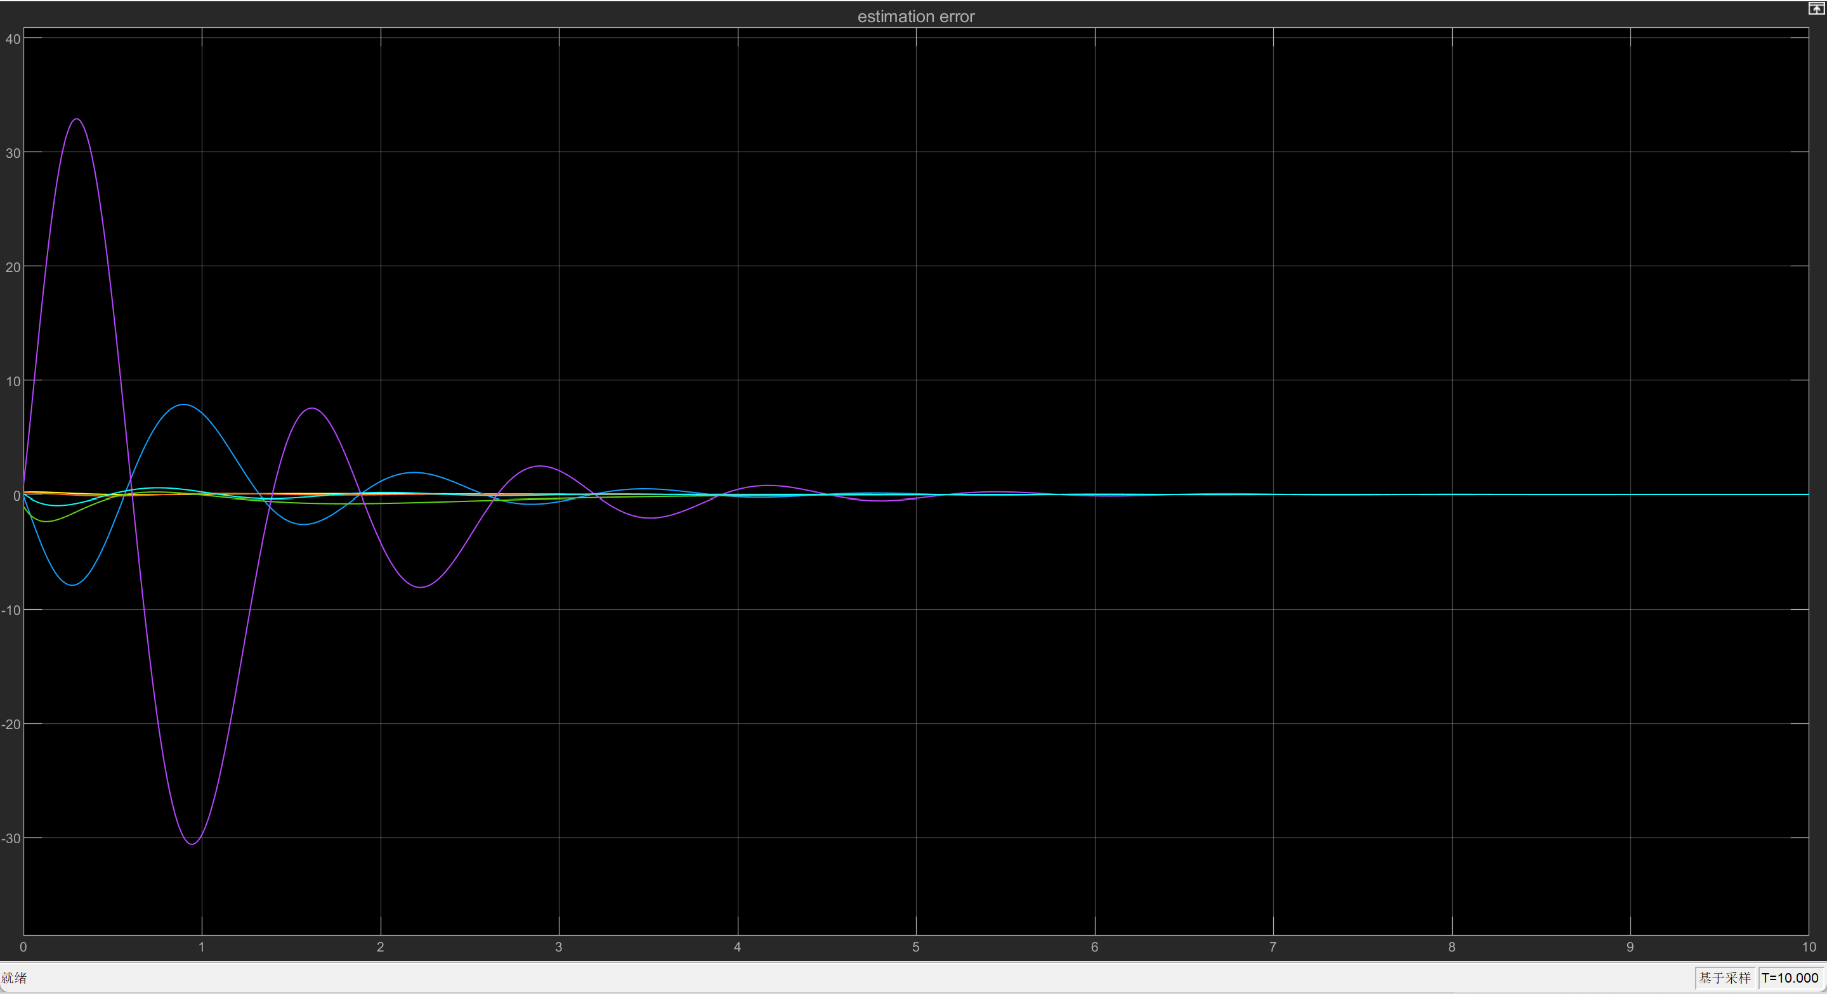

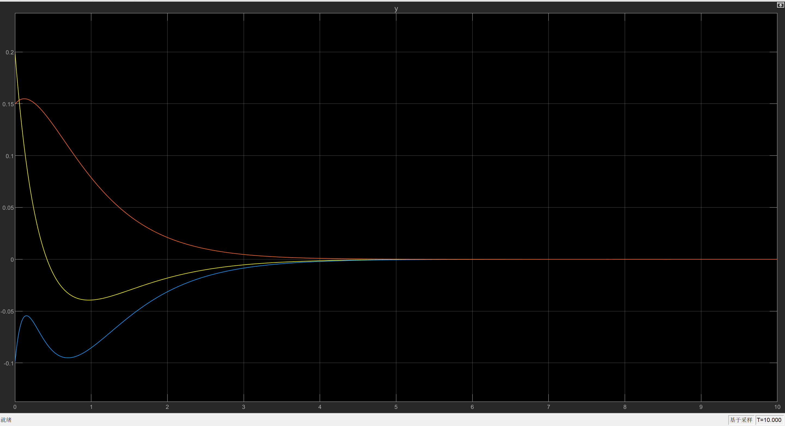

Task2:

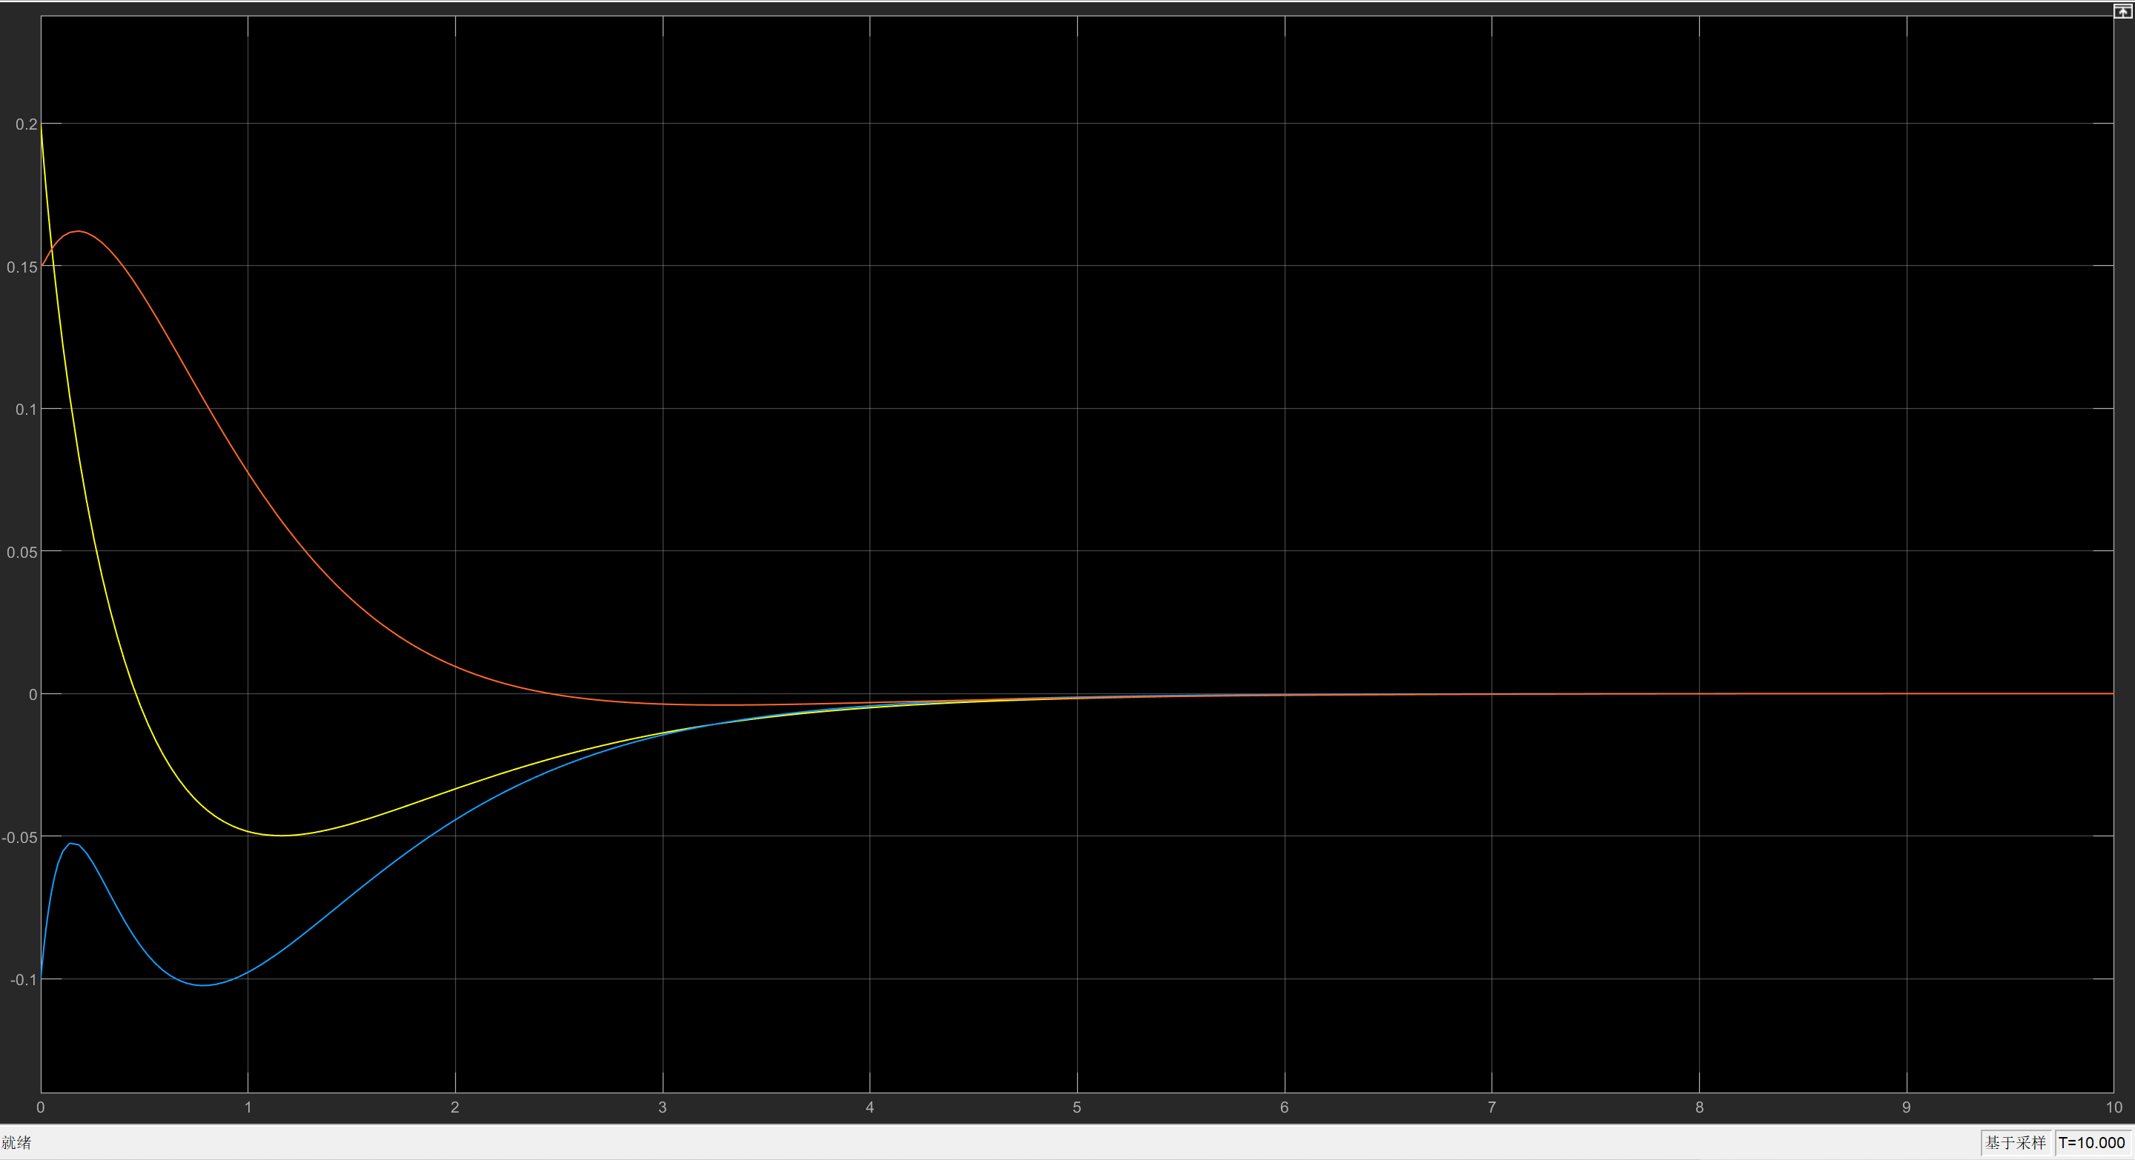

* 1. **Decoupling Control with Two Output**
     1. **Decoupling Controller Design**

A decoupler decouples an MIMO system with equivalent number of input and output terminals, so that every output is affected by only one input. To make the input and output number to be equal, employ the new matrix in equation. Beyond decoupling, since the transient response requirements have to be met, decoupling control with pole placement has to be used.

Set the feedback gain to be . One starts with getting for each row. Since has two rows, . Then the value of , it is the value of such that , where is the first row of matrix . Then it is seen that . Similarly, . Then the matrix is given by:

Then the gain for the state feedback is given by

To get a system meeting the transient response requirements, one need to design with stable characteristic polynomials. Set two sets of stable poles to be:

|  |  |  |
| --- | --- | --- |
| Poles Sets |  |  |
| Set 5 | -1.8-0.872j | -1.8+0.872j |
| Set 6 | -9 | -8 |

Then the two characteristic polynomials can be given as:

Thus,

The result of is displayed in figure.

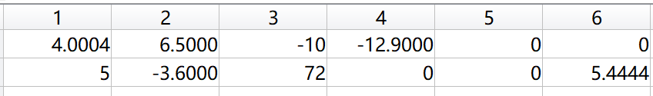

In this case, the feedback gain . Fig. shows the values of .

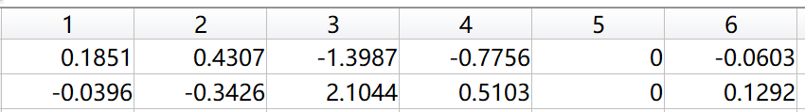

* + 1. **Simulation Results and Internally Stability**

Transient responses of the system with zero initial state are shown in fig. It can be also verified that the system is decoupled, since one input only affects a single output at a time.

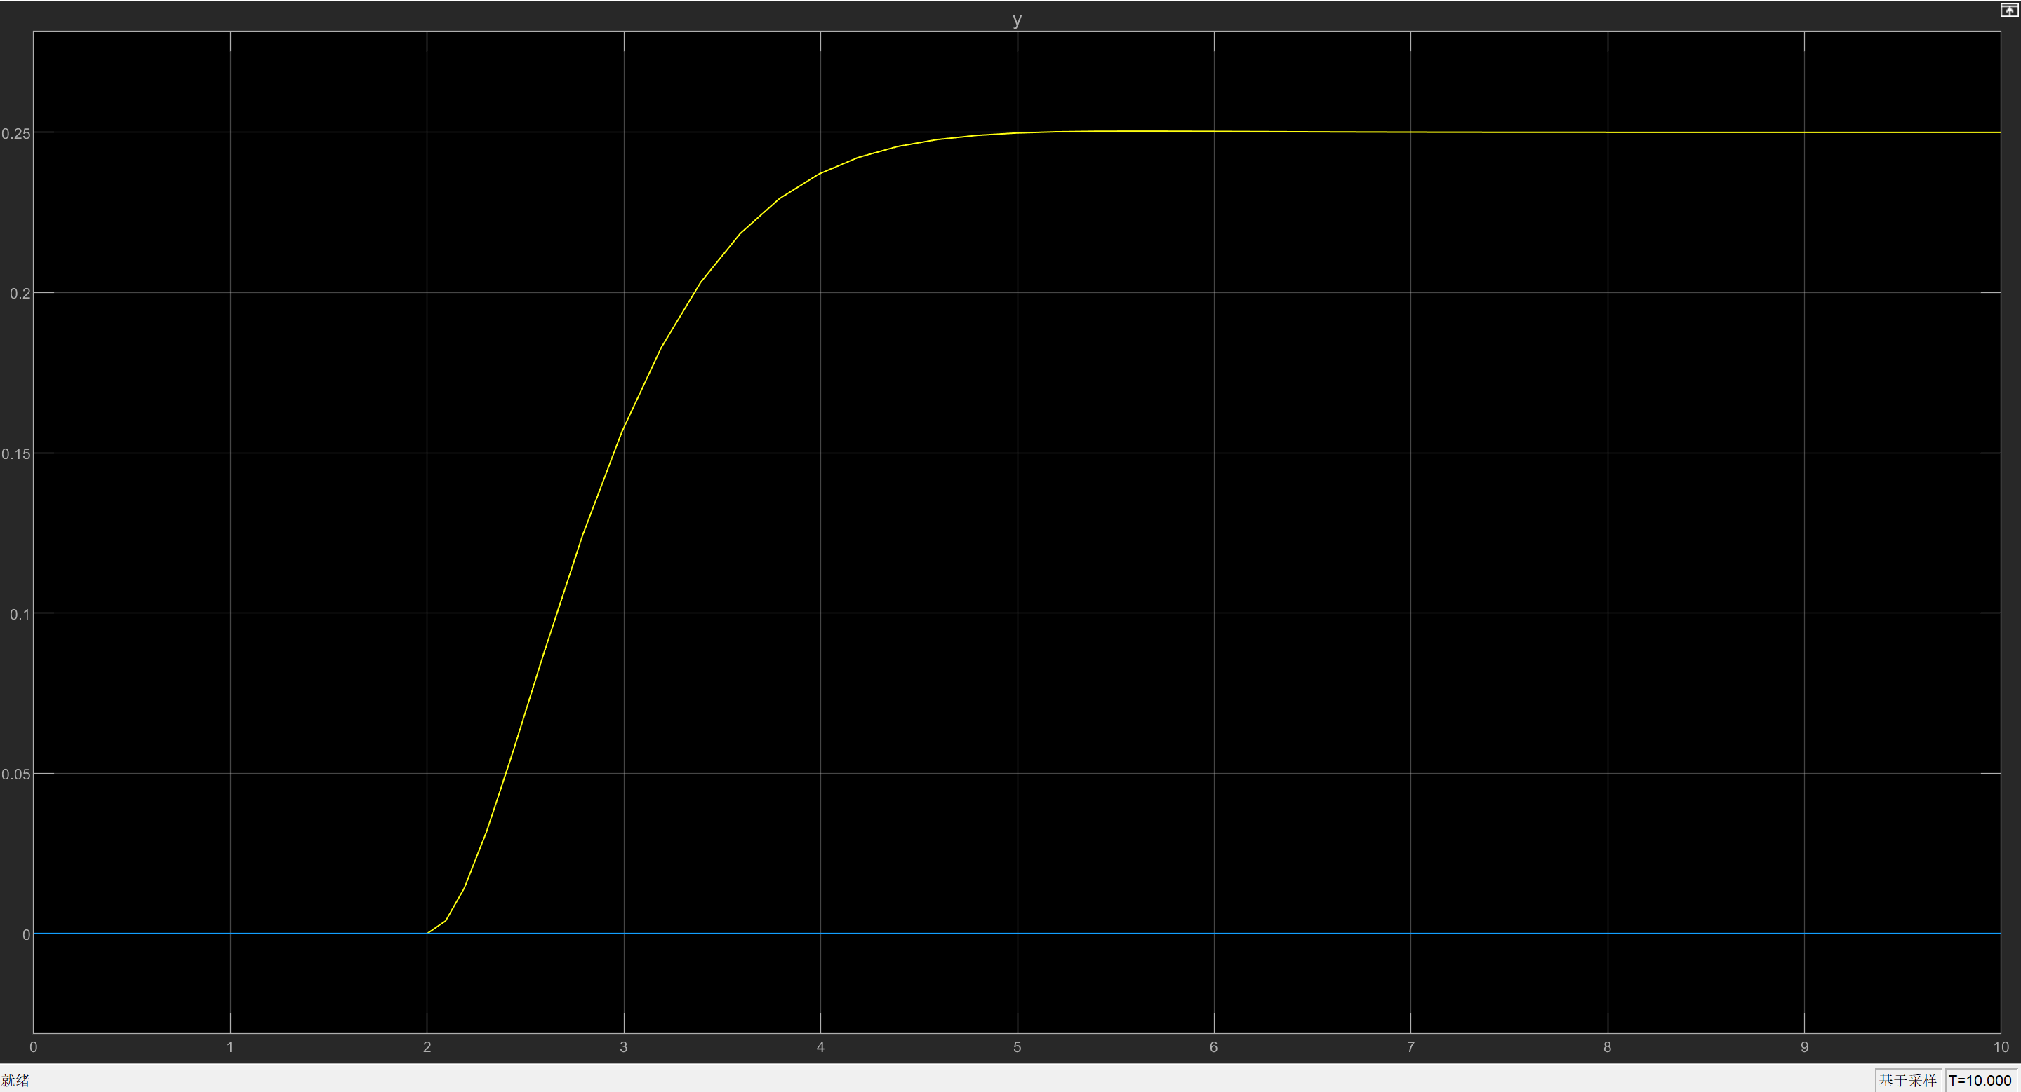

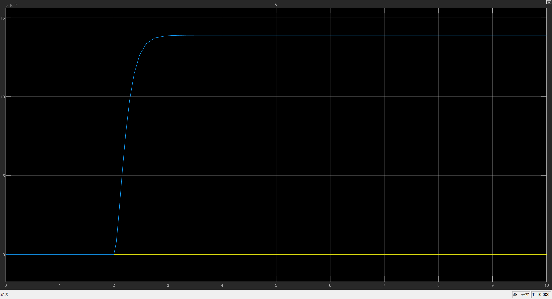

Initial responses with respect to initial state

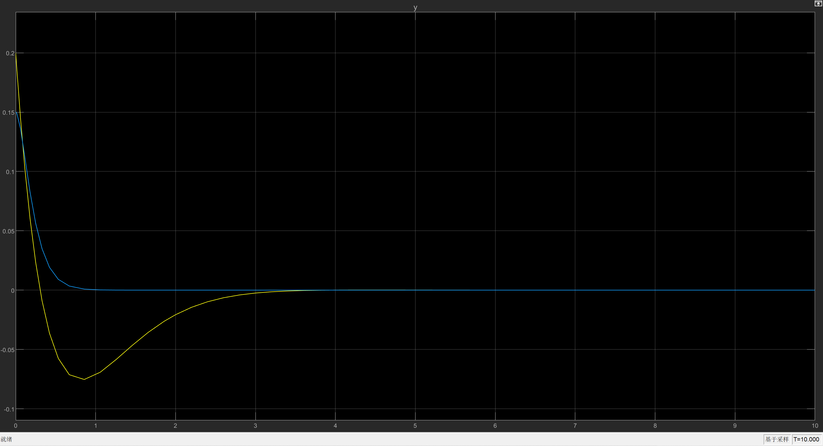

Observe the state of the system for 50 seconds, it can be seen from Fig. That the system state remains stable until the very end of the observation. Thus, the system is not internally stable.

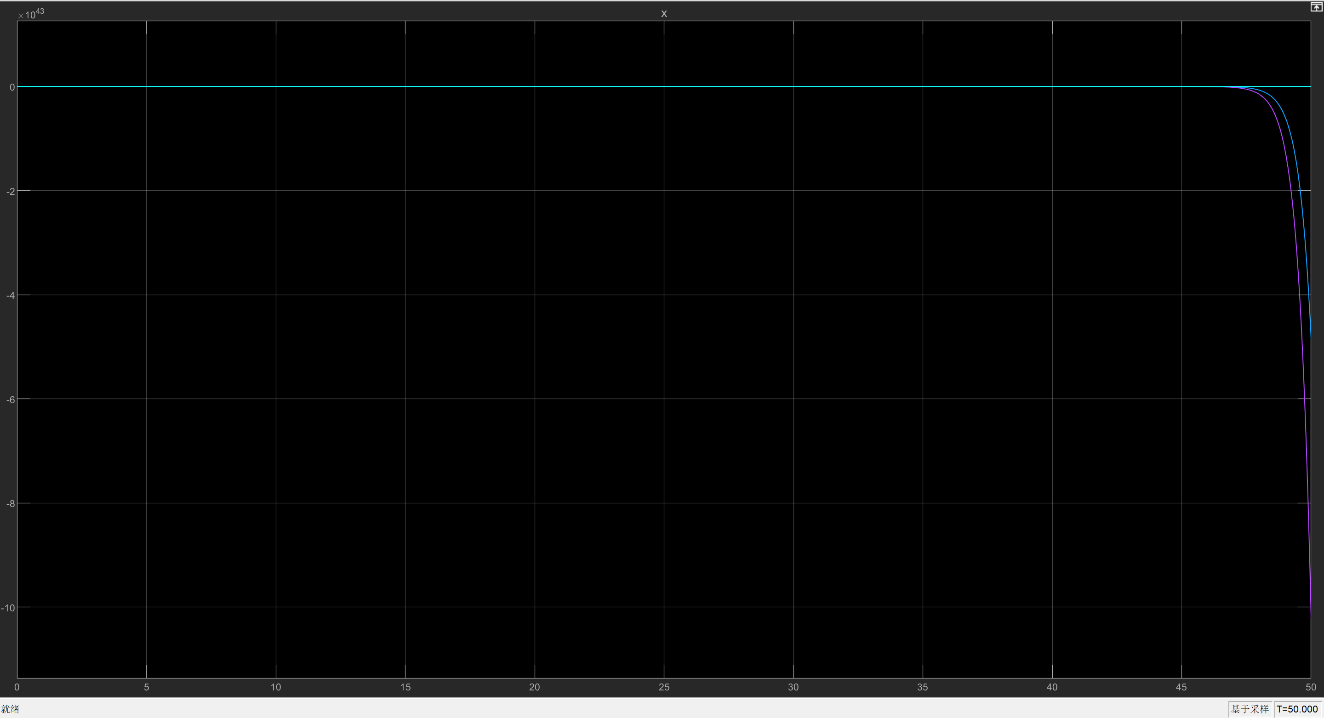

* 1. **Servo Control for a Setpoint**

In this section, a servo control system with estimated state is designed, this is to say that the servo controller takes the estimated state given by the observer as the state feedback signal. The signal, after multiplied with the gain of servo controller, will be fed to the original system. So this section introduces both the servo controller and the observer design to achieve the task.

* + 1. **Controller Design**

Choose integrators as the servo mechanism, and include the integral of error signal between the reference input and the system output into the state to produce an augmented system:

where the disturbance gain and the disturbance signal are:

Thus, the augmented system can be given as:

In this case the disturbance signal is actually directly added to the input signal.

In order to make sure that the error signal can converge to zero, the integral of error signal must converge to a constant. To stabilize the signal , the author uses LQR method. Set the weighting factors to be:

and to be:

Solving the ARE equation and get the controller gain for augmented system as given in Fig.



* + 1. **Observer Design**

Then for the observer, design a full order controller with state space model:

Then find the observer gain , by finding the controller gain of the dual system , where of the original system with poles placement method. Again, one can make use of the full-rank method of pole placement. Set the objective poles to be Set 1 in table, the values in the controller gain matrix are displayed in Figure.

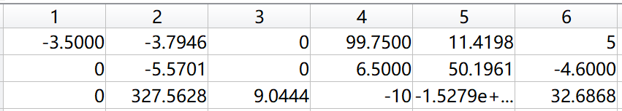

Then the observer gain is as shown in Fig.

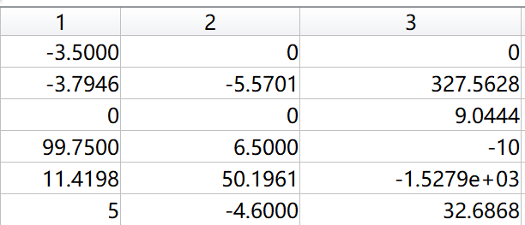

the overall system design is displayed in Fig, with the output of the observer plugged into the servo controller gain input.

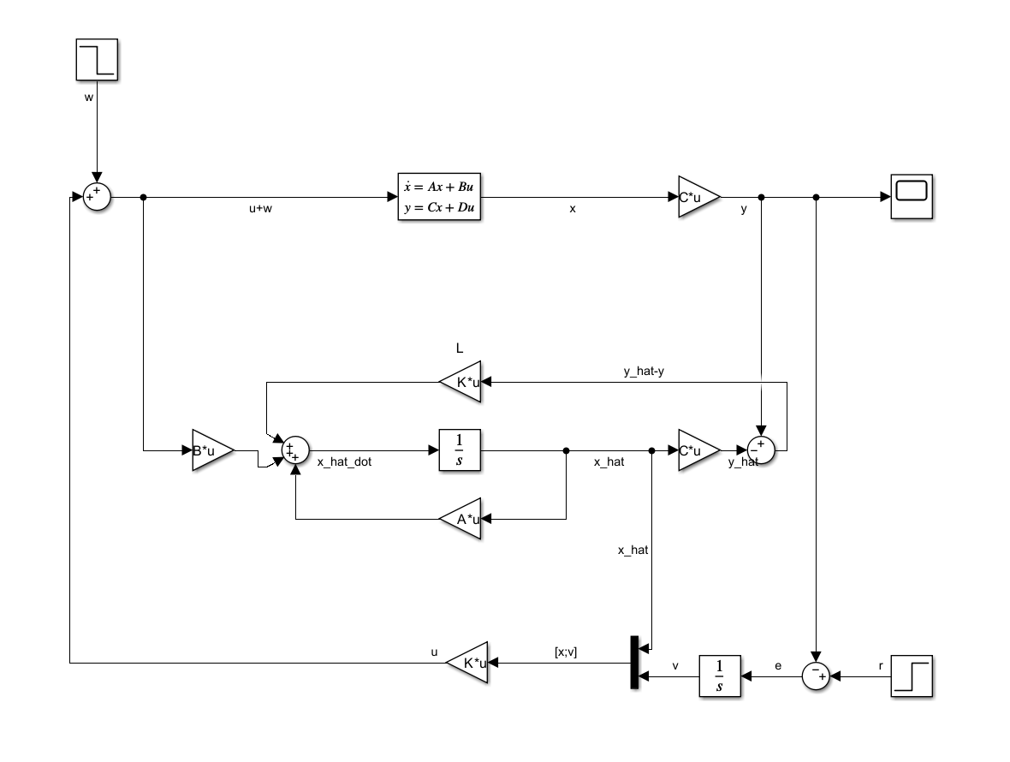

* + 1. **Simulation Results**

As shown in Fig, Fig and Fig, the result transient response of the system shows that the system meets the requirement for transient response.

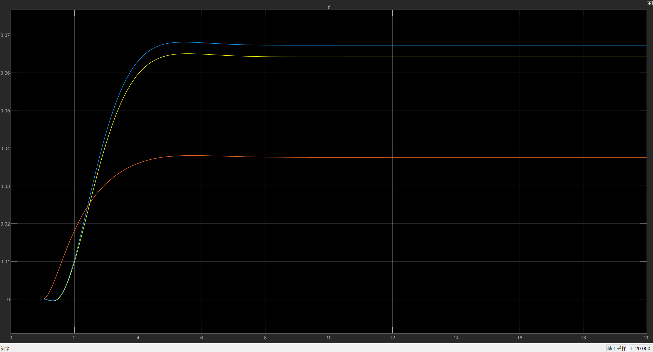

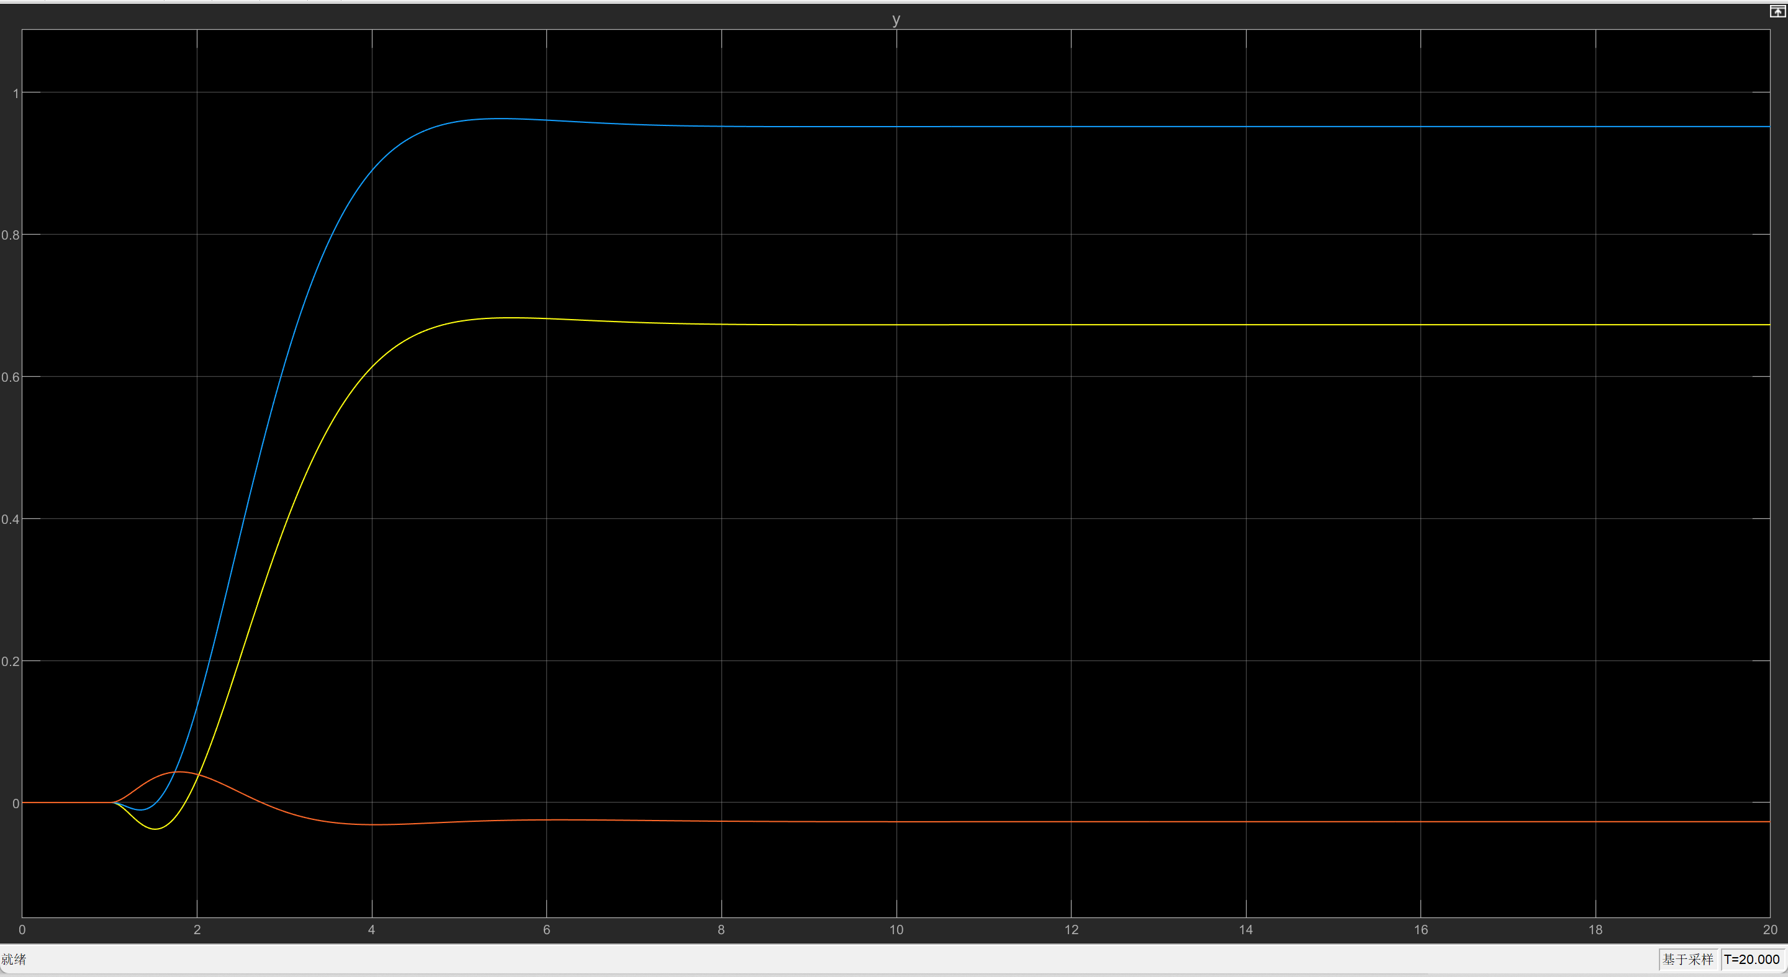

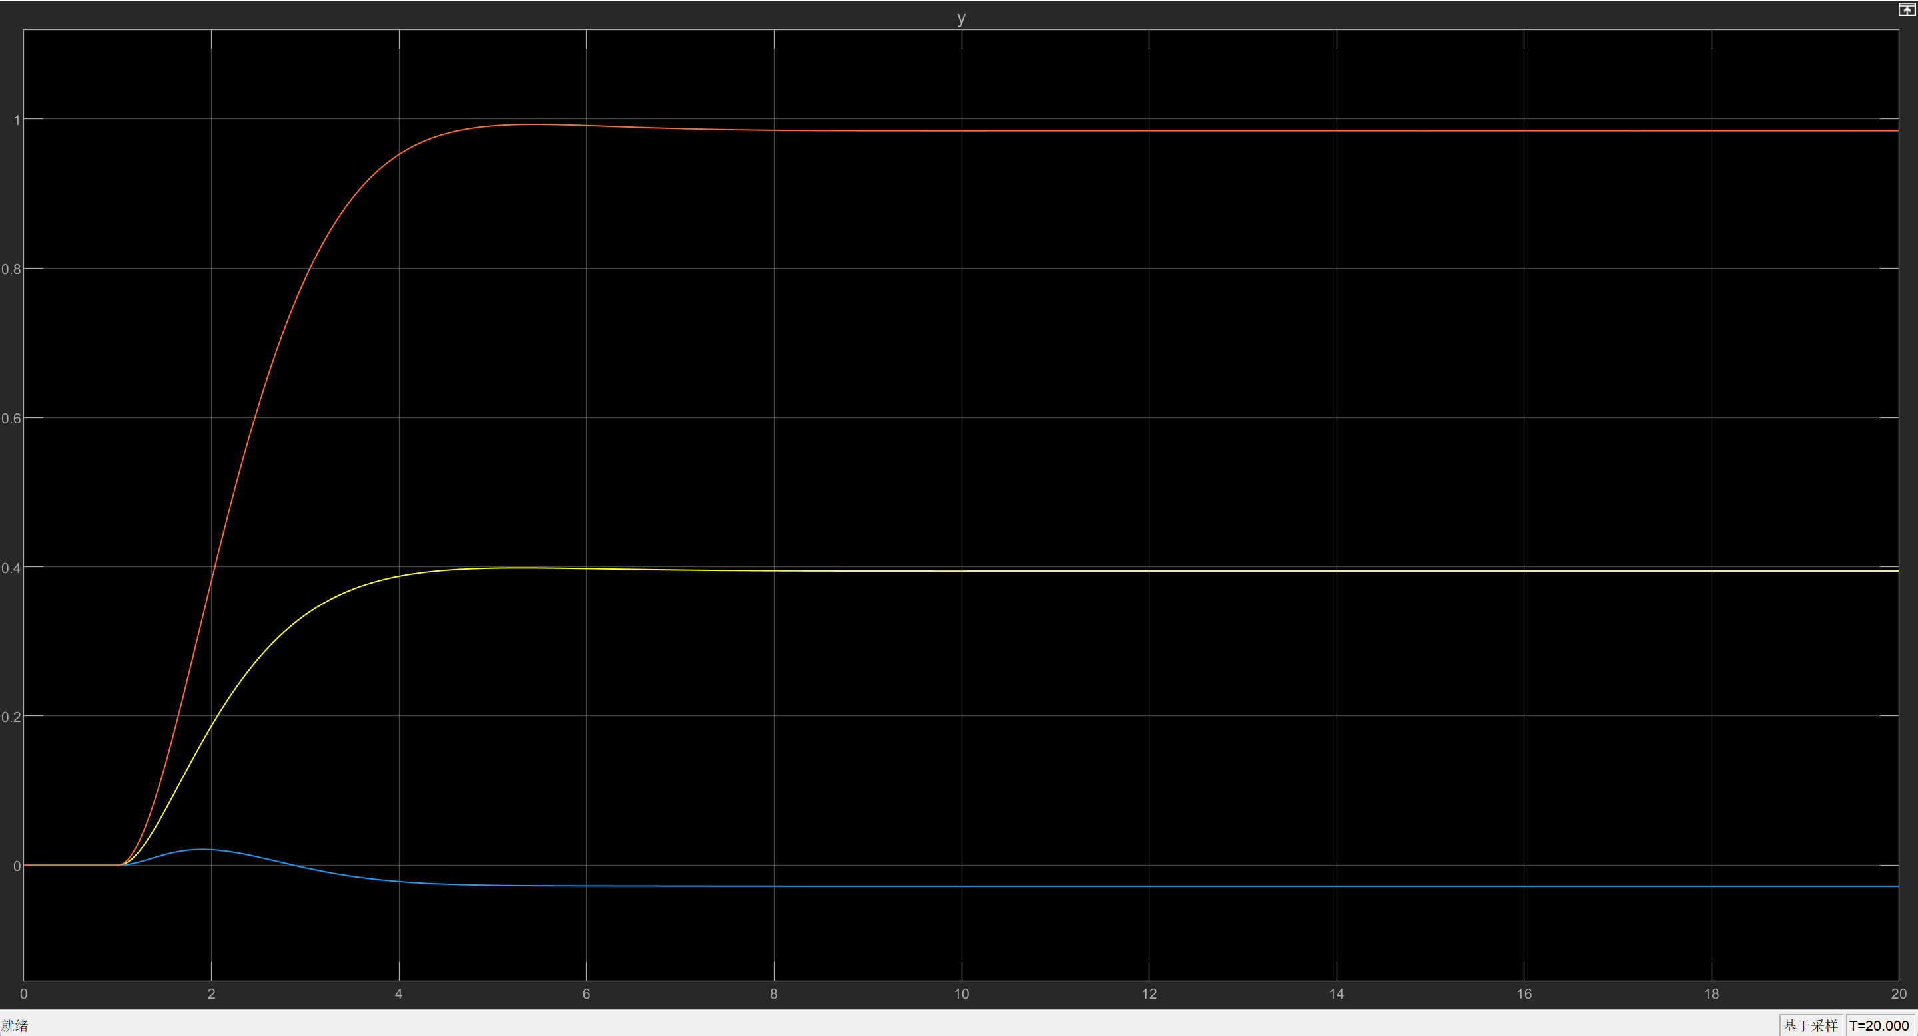

Set the system set points to be that shown in Fig.

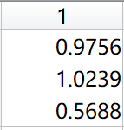

The simulation result with reference input and disturbance shows that the system can converge to reference input even when there are disturbance.

With r and w:

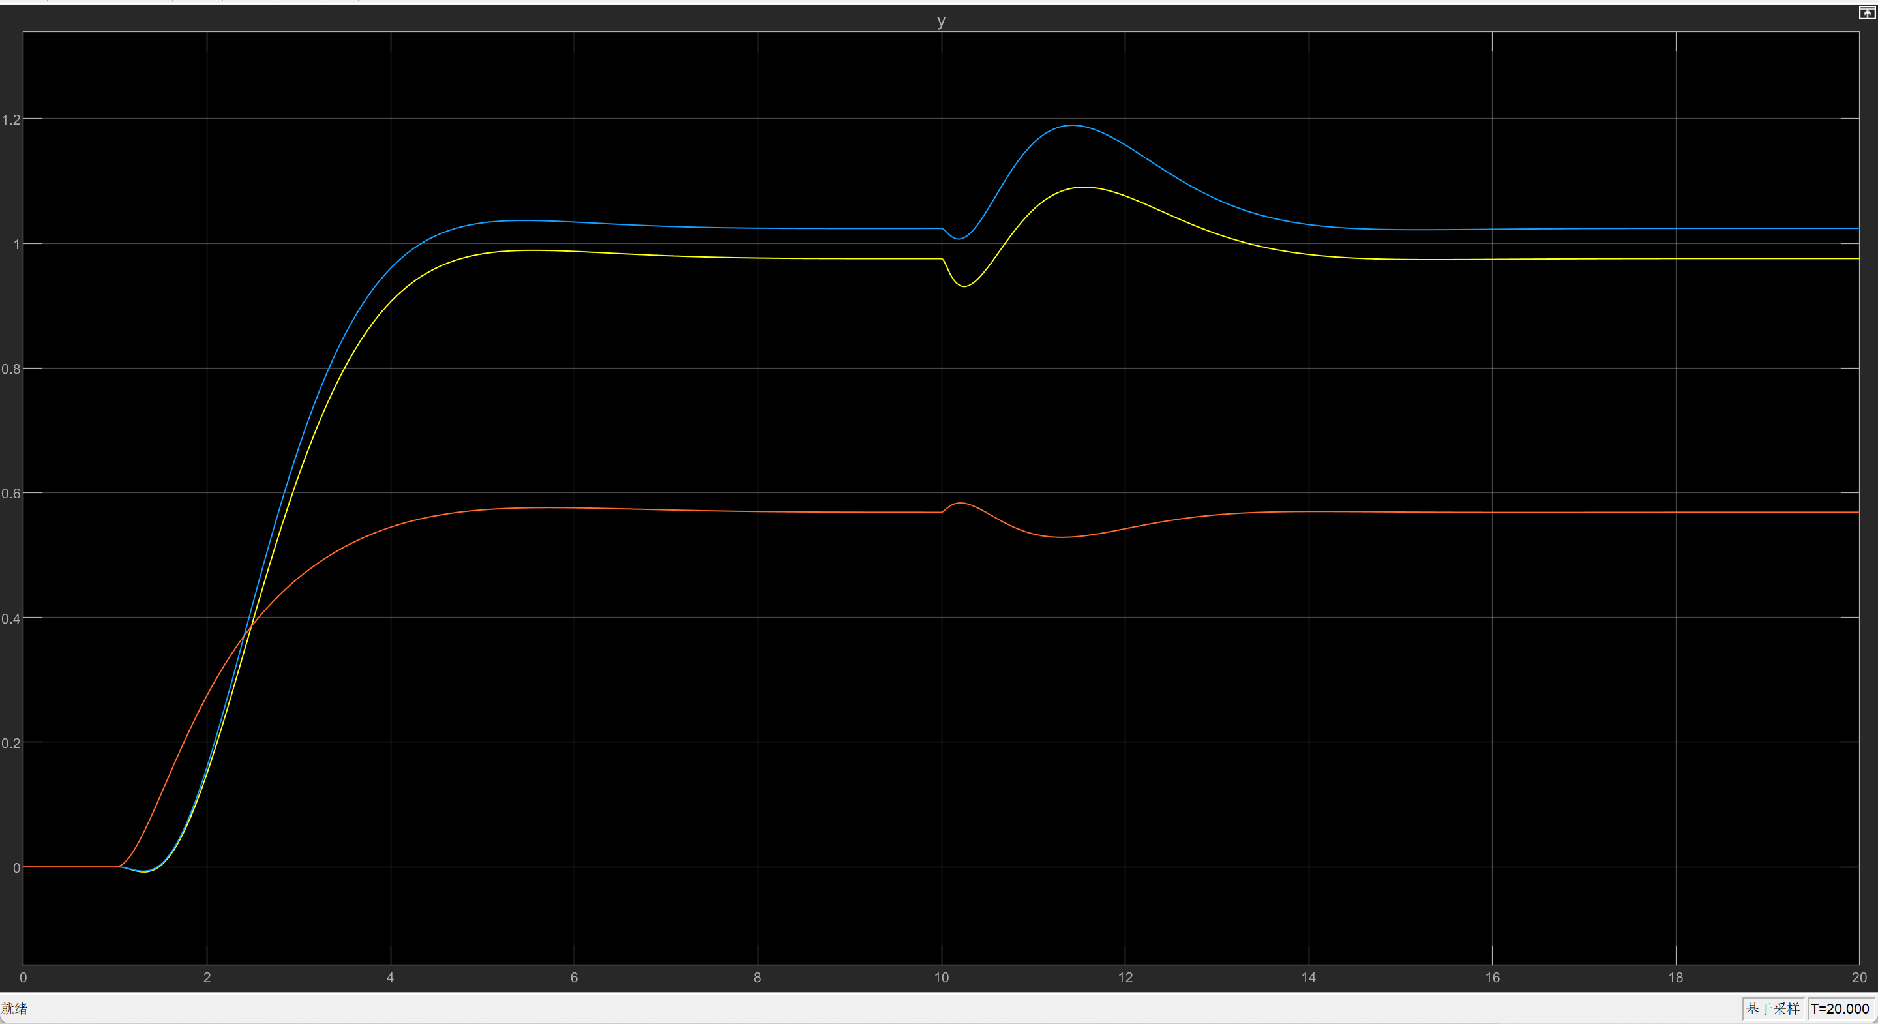

* 1. **Setpoint Problem for Servo Control**

1. **Conclusion**

The project employed different control methods to simulate the control of a real stationary self-balancing two-wheeled vehicle. It is found that for pole placement related stabilization methods, poles that are far away from the origin of the s-plane, produces a system that converges faster for the transient response. Since a value of pole is related to the choice of damping ratio and natural frequency, a large absolute value of pole might result from a bigger damping ratio, which gives a smaller setting time to the system. Besides that, a far stable pole also reduces the size of the control signal.

It is also found that even for the choice of the same poles, the full-rank pole placement method tend to yield a better transient response performance than the unity-rank method. For example, as displayed in Fig, unity-rank method can give large overshoot even for a big damping ratio. However, for the same damping ratio and natural frequency, the full-rank method gives almost no overshoot.

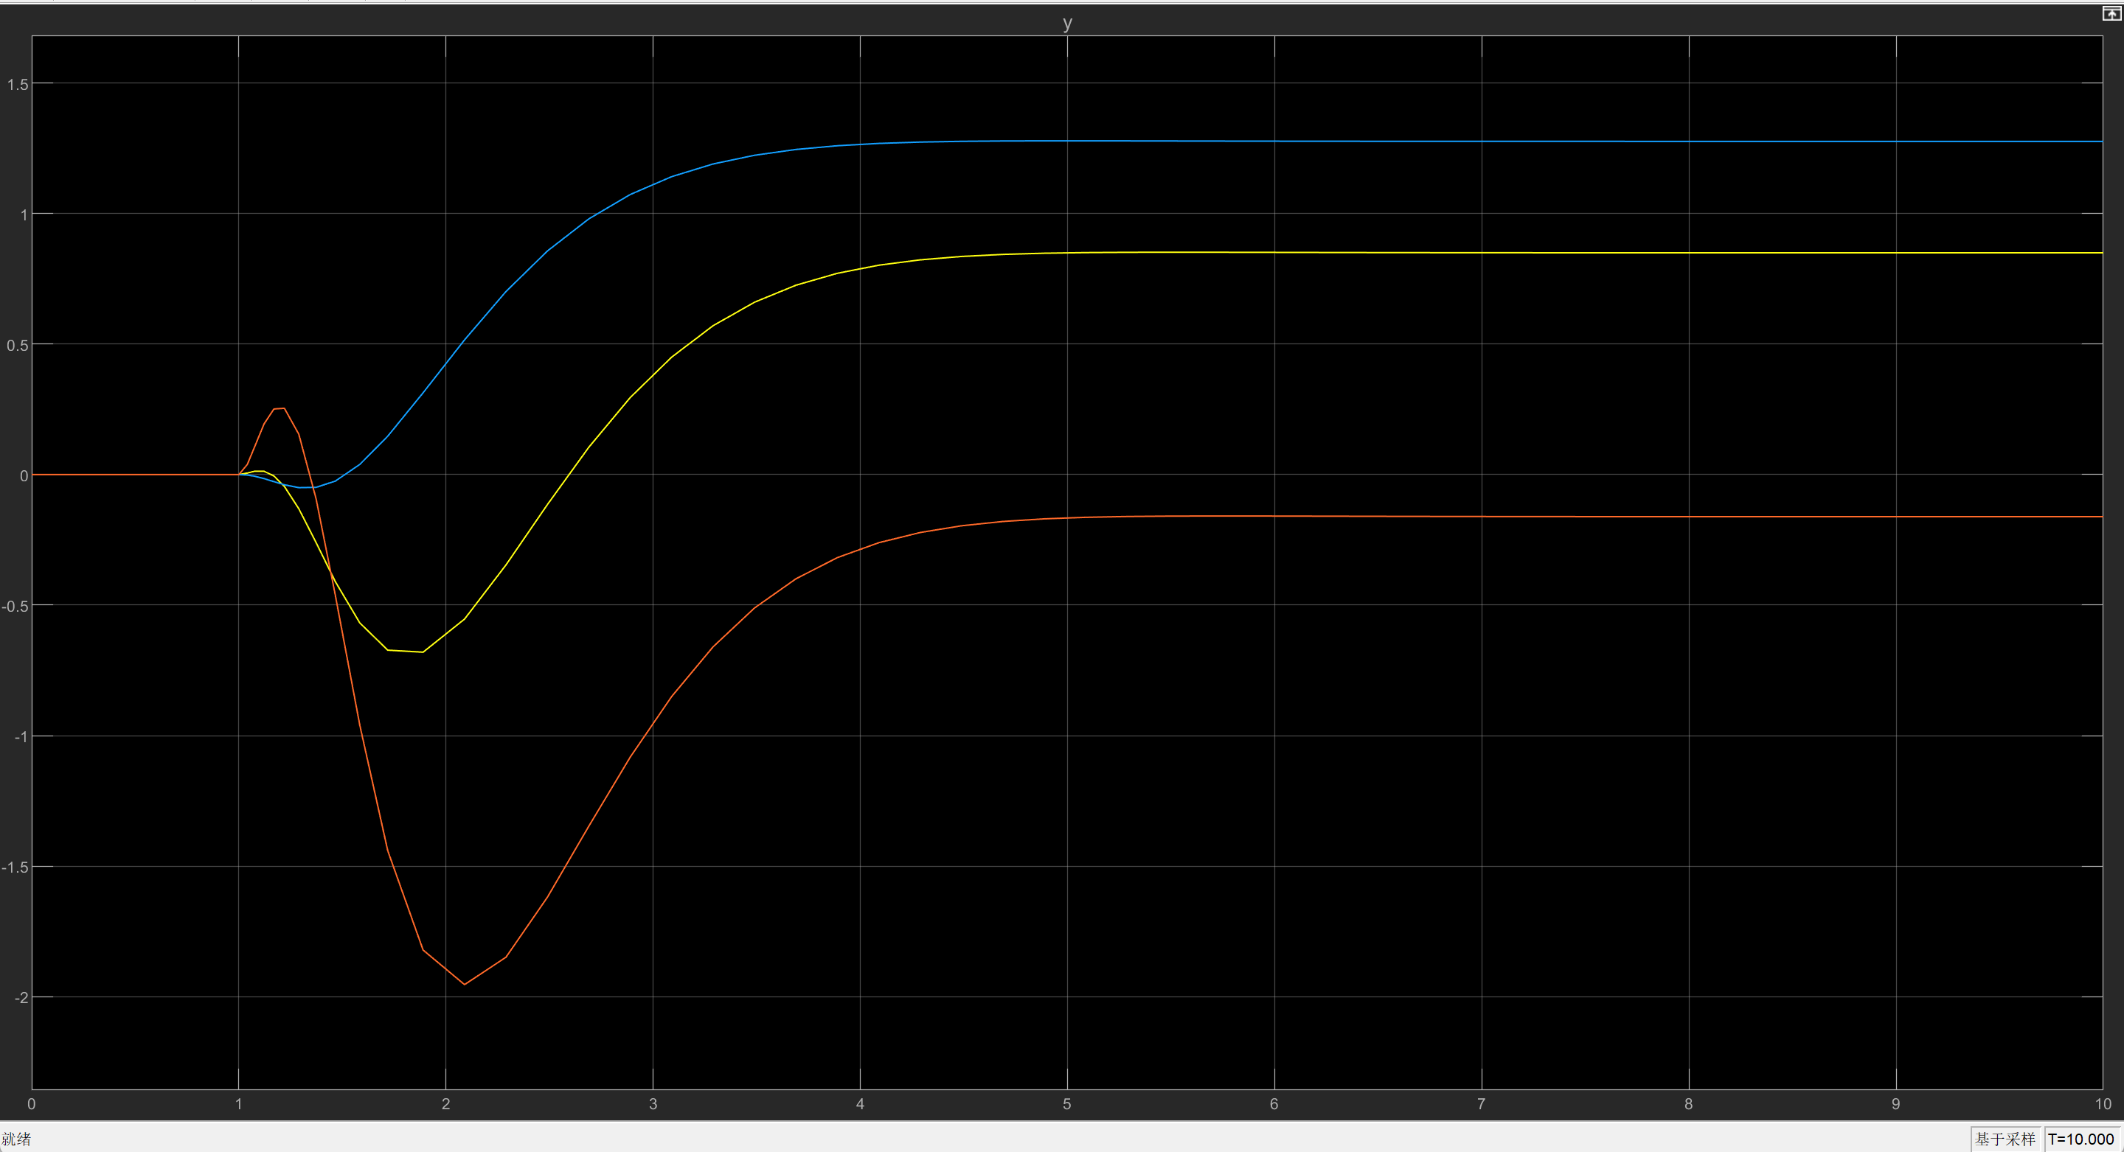

Large negative overshoot is seen for the negative output coloured red in task 1 using unity-rank method, damping ratio equals to 0.9.

For the LQR or LQR based design methods, the choice of the weights and affects the system transient response. Imposing a stronger control on a state or input requires more weights to be put to the corresponding positions in the and matrices.

Appendices